**Desk-Book**

# A PROJECT REPORT

***Submitted By***

# PATEL JAITRY JAYANTIBHAI

### 190180107043

***In partial fulfillment for the award of degree of***

# BACHELOR OF ENGINEERING

***In***

## [Computer Engineering]

# GOVERNMENT ENGINEERING COLLEGE, DAHOD



**Gujarat Technological University , Ahmedabad May , 2023**

 

## Government Engineering College, Dahod Jhalod Road, Dahod, Gujarat 389151

**CERTIFICATE**

### This is to certify that the project report submitted along with the project entitled **Employee Seat Management System** has been carried out by **Patel Jaitry Jayantibhai** Under my guidance in partial fulfillment for the degree of Bachelor of Engineering in computer Engineering, 8th Semester of Gujarat Technological University, Ahmedabad during the academic year 2022-2023

Prof. Dipen Contractor Prof. Viren J Patel

Internal Guide Head of the Department

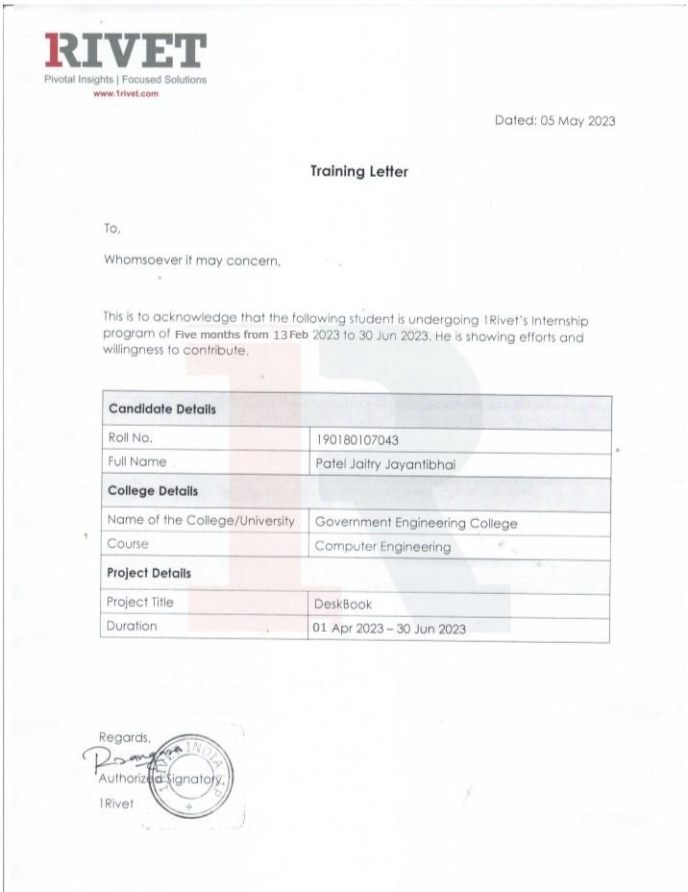

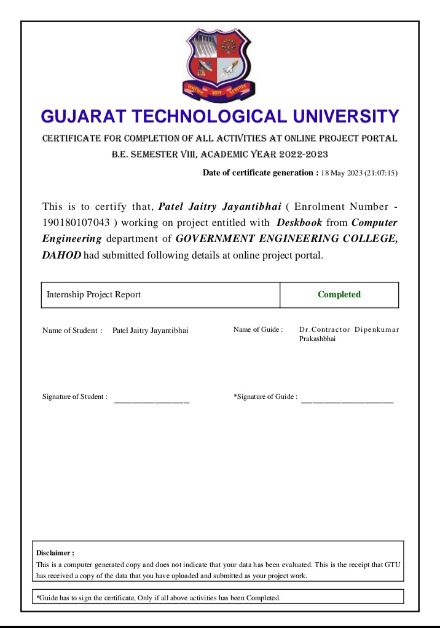

 

## Government Engineering College, Dahod Jhalod Road, Dahod, Gujarat 389151

**DECLARATION**

I hereby declare that the Internship / Project report submitted along with the Internship / Project entitled **Internship At 1Rivet India** submitted in partial fulfilment for the degree of Bachelor of Engineering in Computer Engineering to Gujarat Technological University, Ahmedabad, is a Bonafede record of original project work carried out by me at 1Rivet under the supervision of **Mr. Revant Patel and Mr. Rahul Patel** and that no part of this report has been directly copied from any students’ reports or taken from any other source, without providing due reference.

.

### Patel Jaitry Jayantibhai

### Name of the Student Sign of Student

# ACKNOWLEDGMENT

The internship opportunity I had with **1Rivet India** was a great chance for learning and professional development. Therefore, I consider myself as a very lucky individual as I was provided with an opportunity to be a part of it. I am also grateful for having a chance to meet so many wonderful people an professionals who led me though this internship period.

I express my deepest thanks to **Mr. Revant Patel,** Senior developer of the company for taking part in useful decision & giving necessary advice an guidance an arranging all facilities to make life easier. I choose this moment to acknowledge his/her contribution gratefully.

I would like to **thanks Mr. Dipen Contractor, Computer Department internship mentor** at Government Engineering College, Dahod for their support and advices to get and complete an internship in the above-said organization.

We are thankful to Gujarat Technological University to giving the opportunity for assigning this **Industry Internship** work.

Thank You

Patel Jaitry Jayantibhai

# ABSTRACT

A Deskbook is a software tool that allows employees to reserve and manage their workspace within a shared office environment. It helps organizations to optimize their workspace utilization and allows employees to work more efficiently by reserving a seat in advance. The application allows employees to Book seats and choose from available seats. With a Deskbook application, employees can easily reserve a seat for the Day, Week, or Month, and can also cancel or modify their reservations. It also helps organizations to manage their workspace more efficiently by providing real-time occupancy data, which can help to identify underutilized spaces and make informed decisions about office layout and resource allocation. The primary benefits of a desk booking application are increased productivity and flexibility. Users can reserve a workspace that best suits their needs, eliminating the hassle of searching for an available workspace. The application also provides real- time information on workspace availability, which reduces conflicts and improves communication among users. Additionally, desk booking applications can help organizations optimize their workspace utilization, leading to cost savings and improved efficiency. Overall, desk booking applications are a valuable tool for individuals and organizations looking to manage their workspace effectively and efficiently.

# TABLE OF CONTENT

GOVERNMENT ENGINEERING COLLEGE, DAHOD i

CERTIFICATE ii

ACKNOWLEDGMENT iv

ABSTRACT vi

TABLE OF CONTENT vii

LIST OF FIGURES x

LIST OF TABLES xii

ABBREVIATIONS xiii

CHAPTER 1. OVERVIEW OF THE COMPANY 1

* 1. HISTORY 1
  2. DIFFERENT PRODUCT / SCOPE OF WORK 1
  3. COMPANY VISION 1
  4. COMPANIES OBJECTIVE 2

CHAPTER 2. INTRODUCTION 3

* 1. OVERVIEW 3
  2. PROBLEM DEFINATION 3
  3. SCOPE / APPLICATION 4

2.6 TECHNOLOGY 4

CHAPTER 3. TRAINING ACTIVITIES 5

* 1. TRAINING 5
  2. SNAPSHOTS 6
     1. Sign in 6
     2. Sign Up Role Selection 7
     3. Doctor’s Sign-Up Profile 7
     4. Patient’s Sign-up Profile 8
     5. Pharmacy’s Sign-up Profile 8
     6. Forgot Password 9
     7. Reset Password 9
     8. OTP Verification 10
     9. Doctor’s Home 10
     10. My Patient List 11
     11. Patient’s Details 11
     12. Pharmacies 12
     13. Create Prescription 12
     14. Prescription Template 13
     15. Doctor’s Profile 13
     16. Edit Profile 14

CHAPTER 4. SYSTEM PLANNING 15

* 1. PROJECT DEVELOPMENT APPROACH 15
  2. MODULES 16
     1. Register 16
     2. Log In 16
     3. Book Seat 16
     4. Request History 16
     5. Booking History 16
     6. User Profile 16
     7. Seat Configuration 16
     8. Notification 17
     9. Dashboard 17
  3. FUNCTIONAL REQUIREMENTS 17
  4. NON-FUNCTIONAL REQUIREMENTS 18

4.4 TIMELINE CHART 19

CHAPTER 5. SYSTEM DESIGN 20

* 1. USE CASE DIAGRAM 20
  2. SEQUENCE DIAGRAM 21
  3. ACTIVITY DIAGRAM 22
  4. DATA MODEL 23

CHAPTER 6. IMPLEMENTATION AND TESTING 25

* 1. HARDWARE AND SOFTWARE REQUIREMENTS 25
     1. Hardware Requirements 25
     2. Software Requirements: 25
  2. SNAPSHOTS 26
     1. Register Form 26
     2. Sign-in Page 27
     3. Forget Password 28
     4. Reset Password 29
     5. Loading Page 30
     6. Search Employee 31
     7. Profile of Searched Employee 32
     8. Request History 33
     9. Request Action 34
     10. Notification Page 35
     11. Requested Dashboard 36
     12. Reserved Seat 37
     13. Temporary Unavailable 38
     14. Request Pop-Up 39
     15. Reason Pop-Up 40
     16. Successful Request Pop-Up 41
     17. Booked Seat Information 42
     18. Request Direct Admin 43
     19. Employee Profile 44
     20. Detail Profile 45
     21. Booked History 46
     22. Cancel Confirmation 47
     23. Floor Selection 48
  3. TEST CASES 50

CHAPTER 7. CONCLUSION AND FUTURE SCOPE 52

# LIST OF FIGURES

**Figure 3.2.1 Sign in 6**

**Figure 3.2.2 Sign Up Role Selection 7**

**Figure 3.2.3 Doctor’s Sign-Up Profile 7**

**Figure 3.2.4 Patient’s Sign-up Profile 8**

**Figure 3.2.5 Pharmacy’s Sign-up Profile 8**

**Figure 3.2.6 Forgot Password 9**

**Figure 3.2.7 Reset Password 9**

**Figure 3.2.8 OTP Verification 10**

**Figure 3.2.9 Doctor’s Home 10**

**Figure 3.2.10 My Patient List 11**

**Figure 3.2.11 Patient’s Details 11**

**Figure 3.2.12 Pharmacies 12**

**Figure 3.2.13 Create Prescription 12**

**Figure 3.2.14 Prescription Template 13**

**Figure 3.2.15 Doctor’s Profile 13**

**Figure 3.2.16 Edit Profile 14**

**Figurer 4.1 PROJECT DEVELOPMENT APPROACH 15**

**Figure 4.4 TIMELINE CHART 19**

**Figure 5.1 USE CASE DIAGRAM 20**

**Figure 5.2 SEQUENCE DIAGRAM 21**

**Figure 5.3 ACTIVITY DIAGRAM 22**

**Figure 5.4 DATA MODEL 23**

**Figure 6.2.1 Register Form 26**

**Figure 6.2.2 Sign-in Page 27**

**Figure 6.2.3 Forget Password 28**

**Figure 6.2.4 Reset Password 29**

**Figure 6.2.5 Loading Page 30**

**Figure 6.2.6 Search Employee 31**

**Figure 6.2.7 Profile of Searched Employee 32**

**Figure 6.2.8 Request History 33**

**Figure 6.2.9 Request Action 34**

**Figure 6.2.10 Notification Page 35**

**Figure 6.2.11 Requested Dashboard 36**

**Figure 6.2.12 Reserved Seat 37**

**Figure 6.2.13 Temporary Unavailable 38**

**Figure 6.2.14 Request Pop-Up 39**

**Figure 6.2.15 Reason Pop-Up 40**

**Figure 6.2.16 Successful Request Pop-Up 41**

**Figure 6.2.17 Booked Seat Information 42**

**Figure 6.2.18 Request Direct Admin 43**

**Figure 6.2.19 Employee Profile 44**

**Figure 6.2.20 Detail Profile 45**

**Figure 6.2.21 Booked History 46**

**Figure 6.2.22 Cancel Confirmation 47**

**Figure 6.2.23 Floor Selection 48**

# LIST OF TABLES

**Table 4.3 1** Functional Requirement 17

**Table 6.3 1** Test Cases. 50

## ABBREVIATIONS

HTML - Hypertext Markup Language CSS - Cascading Style Sheet

JS - JavaScript BS - Bootstrap

PHP - Hypertext Pre-Processor

RPA - Robotic Processing Automation SSMS - SQL Server Management Service SSRS - SQL Server Reporting Service

# CHAPTER 1. OVERVIEW OF THE COMPANY

1Rivet is one of the Company, which having many IT Services and IT Consulting in the field of Technology, since very long time. Since 2005, Company have provided premium website designing, software development and marketing expertise to hundreds of companies around the world. With a unique focus on building strong, collaborative relationships with clients, we have created a solid reputation for exceeding our client expectations with quality work and fast delivery turnaround. When you partner with us, you will work with the highest quality development talent and project managers. Our Company are a professionally recognized website designing, internet marketing and software development company having huge experience in developing corporate designing, software development and digital marketing best match to customer's need and requirements. At our Company having expertise in working with a variety of customers from large companies to individuals. Our successful assignments with client companies have established our reputation as superior providers of IT products & services.

## HISTORY

Started in the year 2005 our company is using our creative potential in numerous challenging processes - from generating new ideas of improvements to integrating them by means of business plans. Year by Year company’s growth is increasing in a such a good way. While each of our projects is based on deep market study, we apply our knowledge about it to improve ourselves to produce better ideas for other companies.

## DIFFERENT PRODUCT / SCOPE OF WORK

Performing various kinds of consulting enabled our company to understand the needs of business, both domestic and international. It is the main reason of our advancement in other spheres of business and services .

## COMPANY VISION

Be the company that best understands and satisfies the product, service and self-fulfilment needs of the industry globally. Being a great place to work where people are inspired to be the best they can be.

## COMPANIES OBJECTIVE

* GLOBAL PLANNING
* SUPPORTING YOUR BUSSINESS WORLDWIDE
* PROFESSIONALISM
* RESULT-ORIENTED SERVICE

# CHAPTER 2. INTRODUCTION

## OVERVIEW

* + - A Deskbook is a software tool that allows employees to reserve and manage their workspace within a shared office environment. It helps organizations to optimize their workspace utilization and allows employees to work more efficiently by reserving a seat in advance.
    - The application allows employees to Book seats and choose from available seats. With a Deskbook application, employees can easily reserve a seat for the Day and can also cancel their reservations.
    - It also helps organizations to manage their workspace more efficiently by providing real-time occupancy data, which can help to identify underutilized spaces and make informed decisions about office layout and resource allocation.

## PROBLEM DEFINATION

* + - In many organizations, employees often work remotely or have flexible working arrangements that require them to book desk spaces when they come into the office. However, this process can be time-consuming and frustrating when done manually or through a disjointed system. In addition, the ongoing COVID-19 pandemic has made it essential for companies to manage their office space more efficiently to ensure safe social distancing and contact tracing.
    - Therefore, there is a need for a desk booking application that simplifies the desk booking process for employees while enabling organizations to manage their office spaces effectively. The application should allow employees to book a desk in advance or on the day of their visit, choose their preferred location and amenities, and view availability in real-time. The application should also integrate with the organization's existing systems, such as calendars and employee databases, to streamline the booking process.
    - Furthermore, the application should allow organizations to track desk usage and occupancy rates to optimize office space and ensure compliance with social

distancing guidelines. The application should also provide analytics and insights on usage patterns to help organizations make data-driven decisions about their office space needs.

* + - Overall, the desk booking application should provide a user-friendly and efficient solution for employees to book desks and for organizations to manage their office spaces in a post pandemic world.

## SCOPE / APPLICATION

* + - Desk booking software is a space scheduling tool that can help employees easily book spaces that are most appropriate for their needs, thereby helping to:
    - Eliminate wasted space.
    - Gain insight into which spaces are booked, length of booking, and other key metrics.
    - Create a flexible workplace.
    - Easily manage seat allocation.
    - Reduce friction in the workplace.
    - Maximize employee productivity.
    - Ensure that clean, open spaces are always easily available.
    - Eliminate time spent wasted searching for a proper space.
    - Improve space utilization.
    - Provide the real-time data needed to see trends and plan for future needs.

## TECHNOLOGY

**User Environment:**

* + - Any smart Computer or mobile phone that has Internet Connection.

**Developer Environment:**

* + - Software: VS code
    - Technology: AngularJS
    - Backend: Node.js
    - Database: MSSQL

TRAINING ACTIVITIES

# CHAPTER 3. TRAINING ACTIVITIES

## TRAINING

We were given brief explanation about the technology. We were given different task for week. Modules which we covered are as follows:

* + - Layout: .net multi-platform app ui (.net maui) layout classes allow you to arrange and group ui controls in your application.
    - Validation: validation means controlling user’s input data. There are various elements that controls user data like entry, editor, radio button etc.
    - Data binding: a .net app ui data binding links a pair of properties between two objects, at least one of which is usually a user-interface object
    - Mvvm(model view model): the view is responsible for defining structure, layout, and appearance of what the user sees on screen. The model contains the business logic.

The view model connects the view and view model.

* + - Navigation: navigation is used for navigating from one page to another.
    - Collectionview: collectionview is a view for presenting list of data using different layout specifications.
    - Remote data access: remote data access involves making a request to an api endpoint that is hosted on a remote server, which then returns the requested data to the client making the request.

After we have completed the Tasks, our mentor assigned us a dummy project **1Medify**.

As a Doctor, Pharmacist, and Patient, the user should be able to access the system.

Pharmacist and Patient can search patient’s medical prescriptions and can send it to the doctor for their approval. Doctor can create prescriptions and add into the system, and the user (Pharmacists, Patients) can print approved prescriptions.

* + - In the system, there will be a list of doctors, a list of the patients, and a list of the pharmacy store.
    - Doctor can create and add the prescription into the system.
    - Doctor can write and upload prescription into the system.
    - Prescription acceptance time will be 10 minutes for each doctor, after 10 minutes if the doctor does not take any relevant actions (Accept, Reject, Busy), then it will be sent to another doctor for their approval.
    - If the doctor is busy, then doctor can click on busy button, and the prescription will automatically send to another doctor.
    - Patients and pharmacists can upload and send prescription for doctors’ approval. • System will send prescriptions from one doctor to another doctor on the priority list:

## SNAPSHOTS

## Sign in

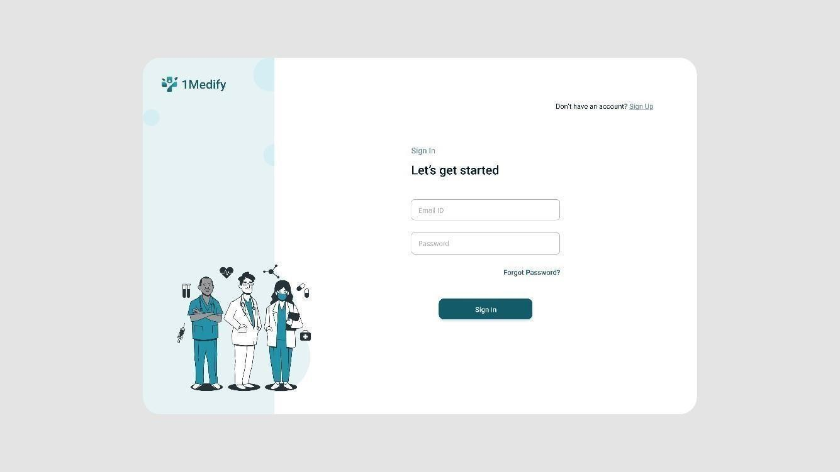

[Figure 3.2.1] Sign in

User can Sign in to their account by using their registered Email id .

## Sign Up Role Selection

TRAINING ACTIVITIES

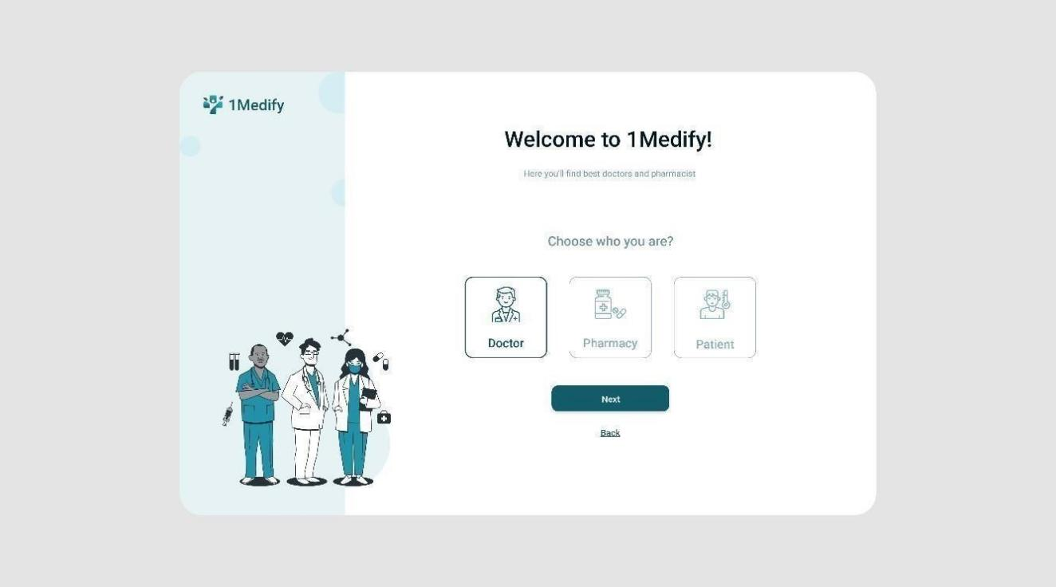

[Figure 3.2.2] Sign Up Role Selection

Allows user to register in the application and process and redirect to the Sign In page.

## Doctor’s Sign-Up Profile

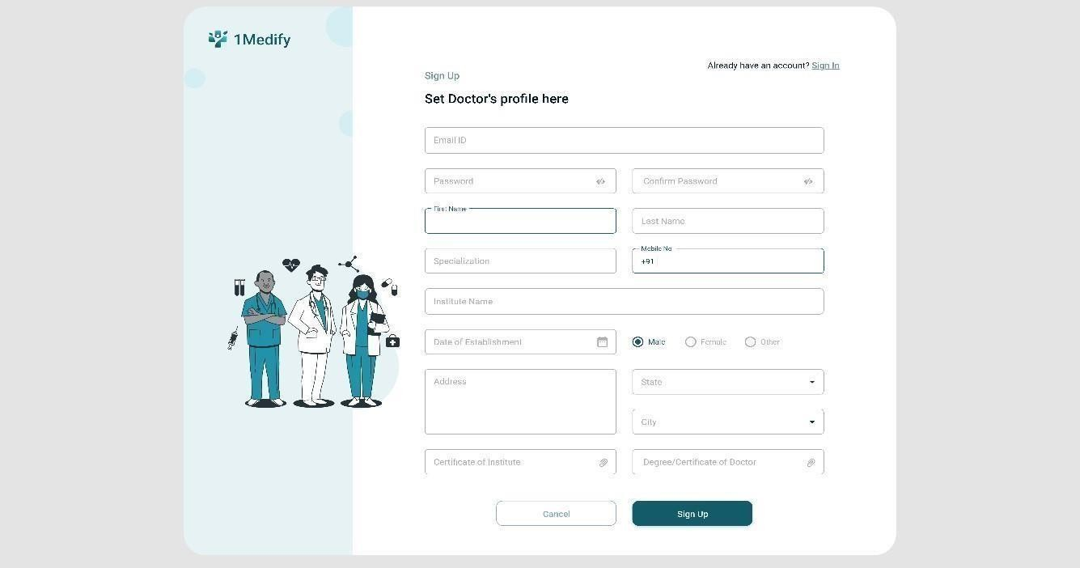

[Figure 3.2.3] Doctor’s Sign-Up Profile Allows Doctor’s to Register themselves by giving required details.

## Patient’s Sign-up Profile

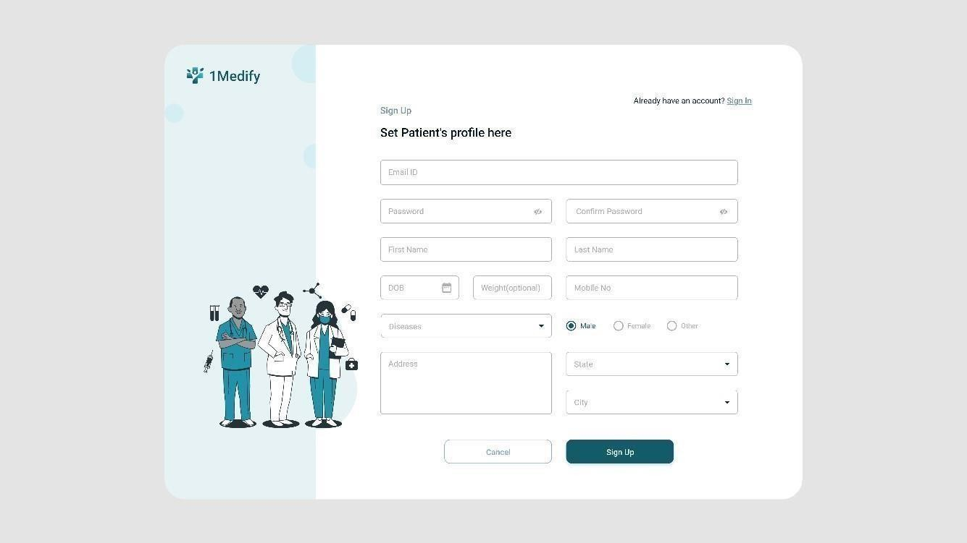

[Figure 3.2.4] Patient’s Sign-up Profile Allows Patients to Register themselves by giving required details.

## Pharmacy’s Sign-up Profile

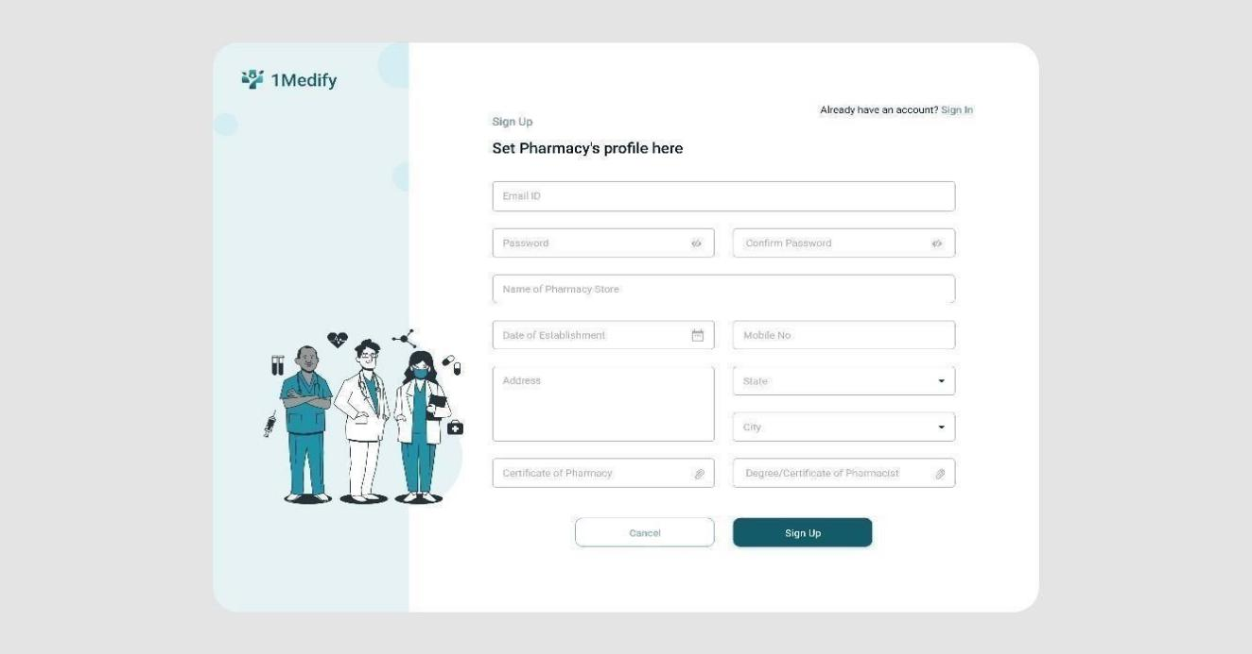

[Figure 3.2.5] Pharmacy’s Sign-up Profile Allows Pharmacy to Register themselves by giving required details.

## Forgot Password

TRAINING ACTIVITIES

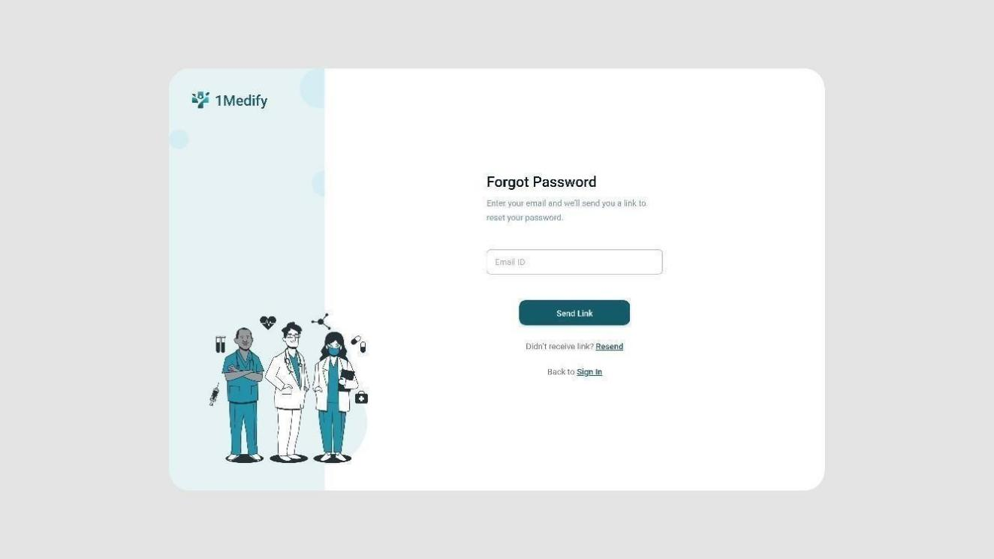

[Figure 3.2.6] Forgot Password

If user forgets their password then user can get reset link by entering registered email id.

## Reset Password

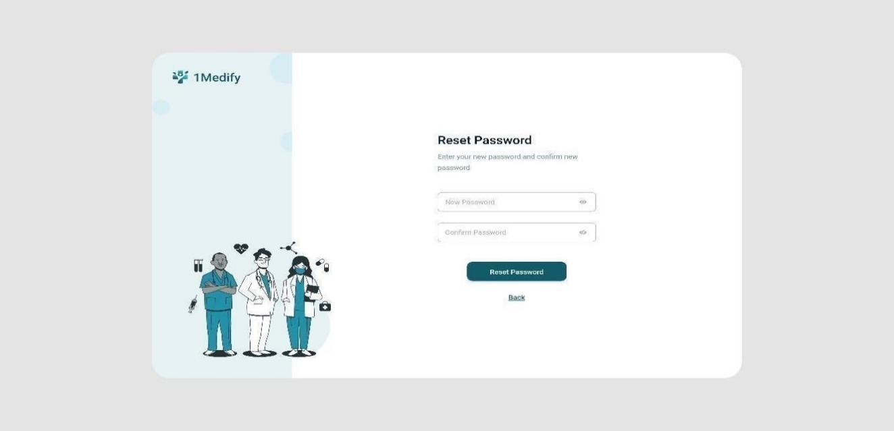

[Figure 3.2.7] Reset Password

User can navigate to this page by clicking the link which they get on their email id which they entered on forgot password page.

## OTP Verification

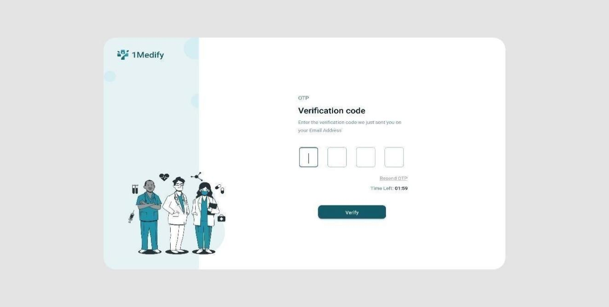

[Figure 3.2.8] OTP Verification

When user clicks on Reset password user get an otp on their registered email.

## Doctor’s Home

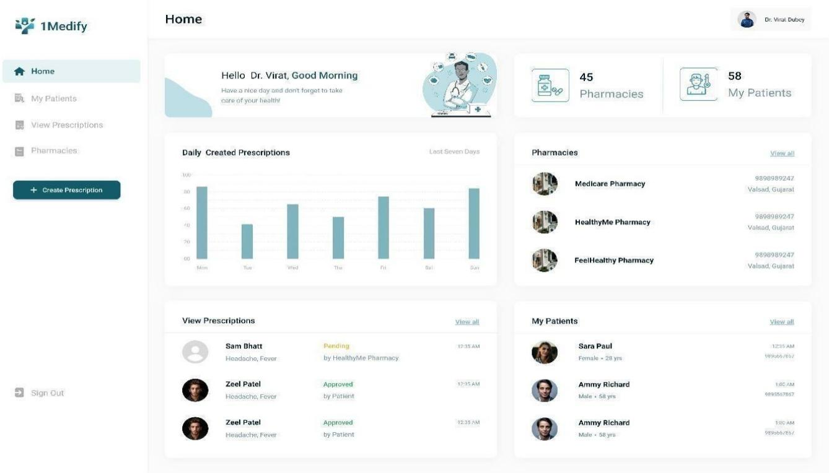

[Figure 3.2.9] Doctor’s Home

Doctor’s can see their patient’s, available pharmacies, update their profile, create prescription

## My Patient List

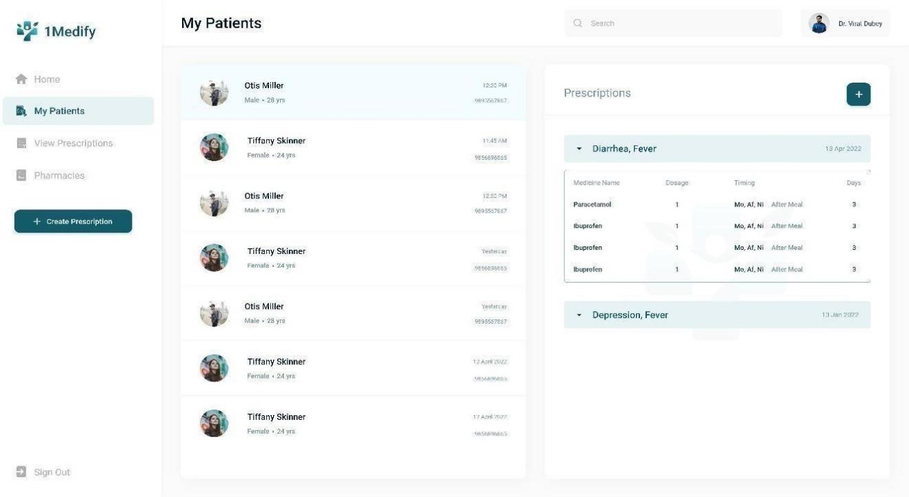

[Figure 3.2.10] My Patient List Doctor’s can see their patient’s list here and search patient.

## Patient’s Details

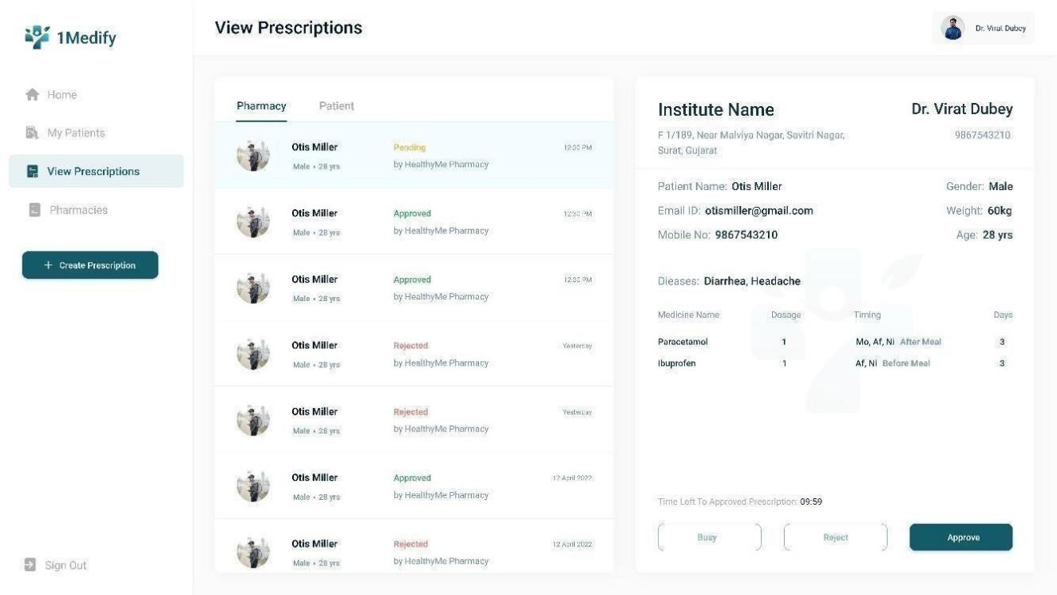

[Figure 3.2.11] Patient’s Details Doctor’s can see their patient’s details

## Pharmacies

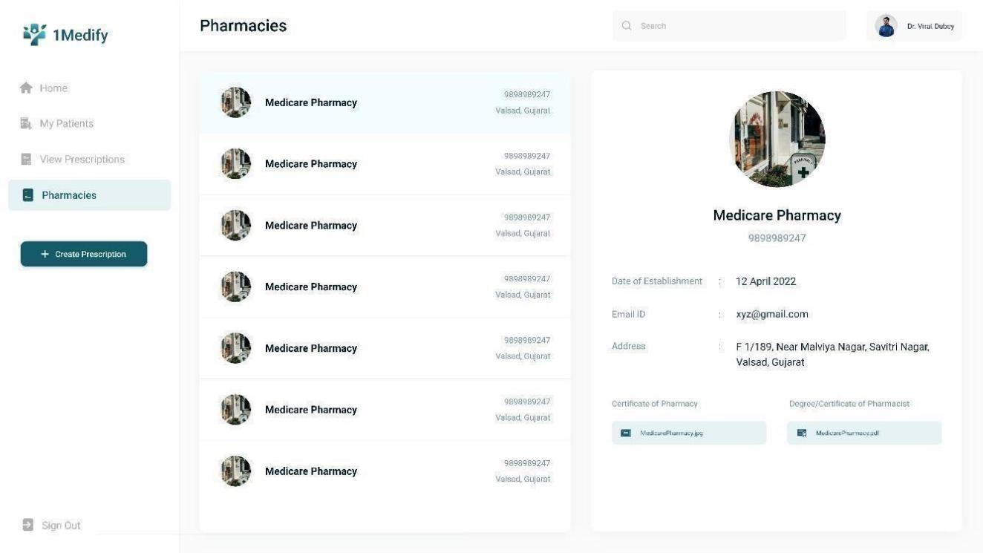

[Figure 3.2.12] Pharmacies

Doctor’s can see the available pharmacies here.

## Create Prescription

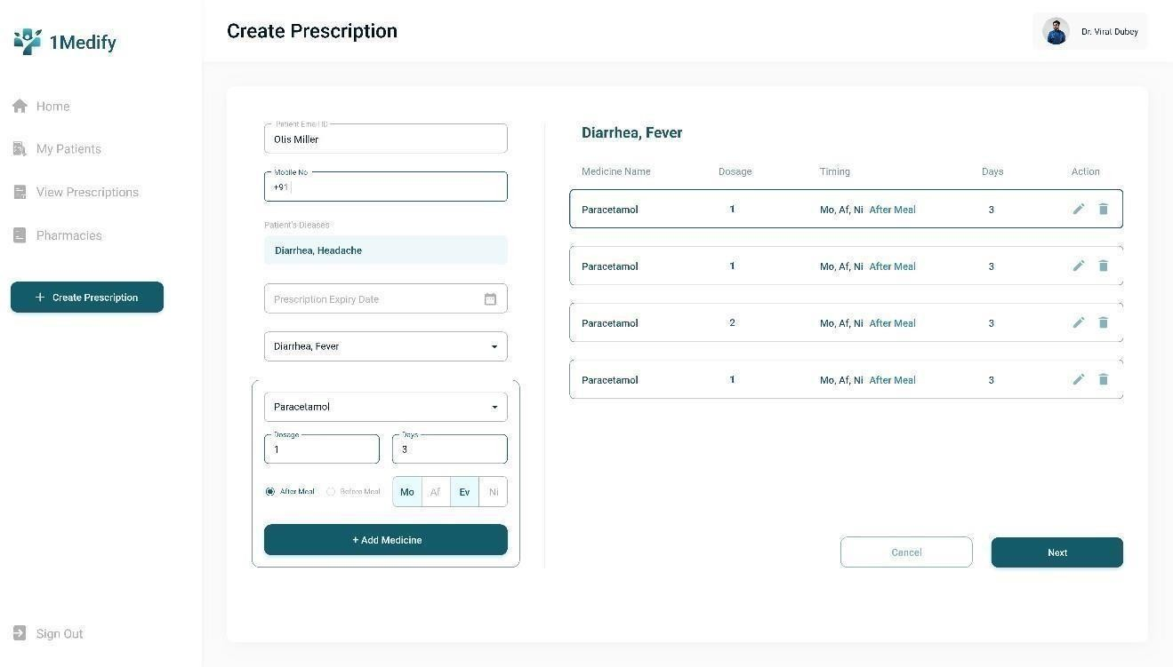

[Figure 3.2.13] Create Prescription Doctor can create the prescription for patients .

## Prescription Template

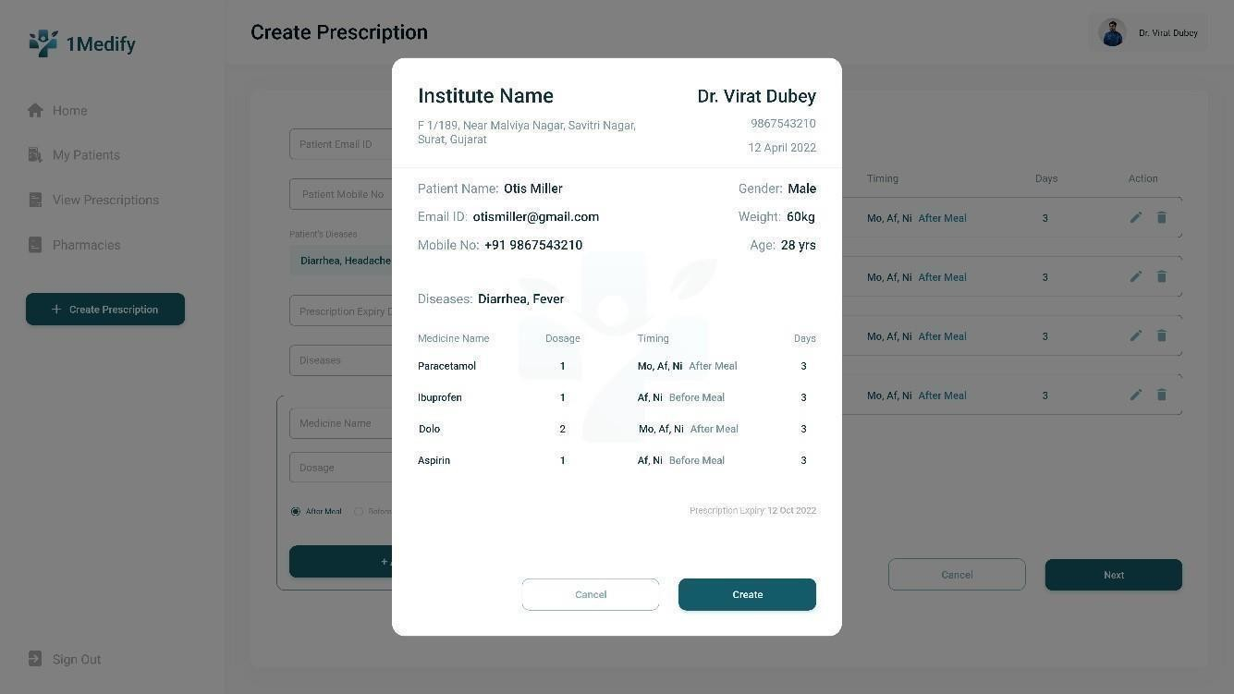

[Figure 3.2.14] Prescription Template Allows user to see the prescription and can print the prescription.

## Doctor’s Profile

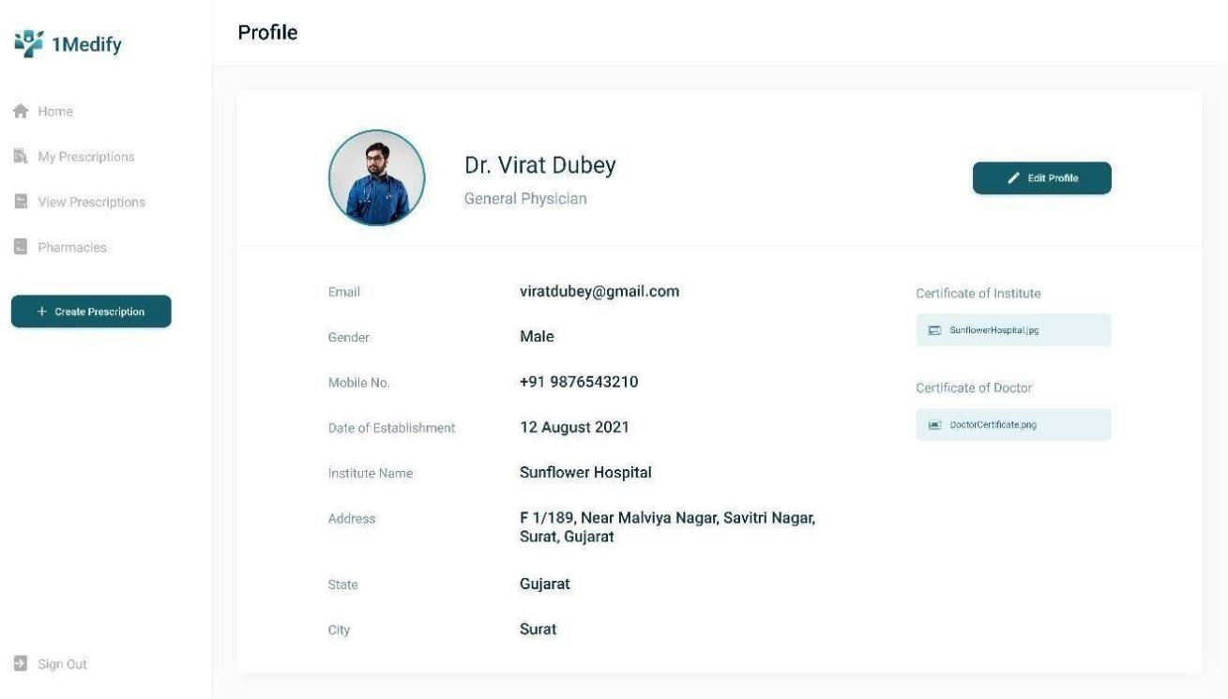

[Figure 3.2.15] Doctor’s Profile Allows Doctor’s to see their profile and can sign Out from the profile

## Edit Profile

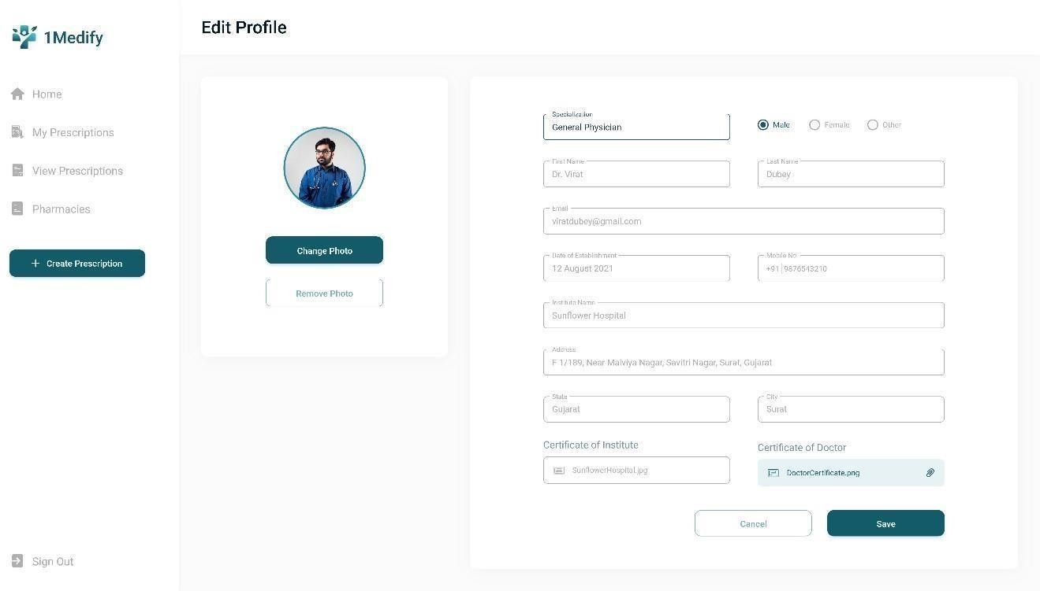

[Figure 3.2.16] Edit Profile

Allows Doctor’s to Edit their Profile.

# CHAPTER 4. SYSTEM PLANNING

## PROJECT DEVELOPMENT APPROACH

* + - **Agile Process Model:** This is an iterative and collaborative approach that involves working closely with the client to develop and deliver the software in small, incremental stages. It emphasizes frequent communication, continuous feedback, and adaptability to change, which can be particularly useful in complex and rapidly changing projects.
    - **Advantages of Agile Process Model:**
    - Generates working software quickly and early during the software life cycle.
    - It is easier to test and debug during a smaller iteration.
    - Clients can respond to each build.
    - Lowers initial delivery cost.

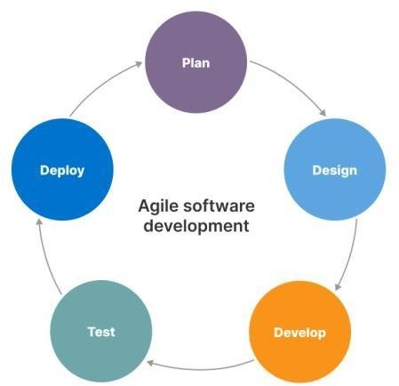

[Figure 4.1. 1] Agile software development

## MODULES

## Register

The system shall allow the user to click on the " Register " button only when all the required fields are filled with valid input. Once the user clicks the " Register " button, the system shall process and redirect to the Sign In page.

## Log In

The user can log in to the Deskbook. Application so that the user can have access to the application.

## Book Seat

Users can book the seat as per the availability.

## Request History

The user can view all the requests made by the employee. User can “Accept” or “Reject” the request made by the employee.

## Booking History

User will be able to view seat bookings and cancel their seat booking on clicking the “Booking History”.

Booking history will display:

* The seat booked by the user.
* It will also display the position of the seat on the floor.
* Time duration.
* Date Of Reservation

## User Profile

This user Profile will be on the home page and will redirect the user to the Profile page. The profile page will display the user information. This will provide the functionality to manage the profile details.

## Seat Configuration

The user should be able to add new seats or remove the seats as per the requirement.

## Notification

The user should receive Notification for Requested Seat, Booked Seat and Cancelled seat. The user should Receive Notification for Request sent for seat to Hybrid user for Accept the seat or Reject the Seat.

## Dashboard

This section is only visible to the admin, admin can login to see various data regarding the activities done in the system.

## FUNCTIONAL REQUIREMENTS

[Table 4.3 1] Functional Requirment

|  |  |
| --- | --- |
| **ID** | **Title and Description** |
| FR1 | Title: User Registration and Authentication  Desk: The application should allow users to register and create an account. Users should be able to log in to the system securely. |
| FR2 | Title: Desk Reservation  Desk: Users should be able to browse available desks and reserve a desk that meets their needs. They should be able to specify the date and time of the reservation, as well as any special requirements they may have |

|  |  |
| --- | --- |
| FR3 | Title: Desk Availability  Desk: The application should provide up-to-date information on the availability of desks, including real-time updates to desk availability. |
| FR4 | Title: Desk Allocation |
|  | Desk: The application should allocate desks to users based on their preferences and availability. Users should be able to specify their preferred location, type of desk, and any other requirements. |
| FR5 | Title: Desk Management:  Desk: The application should allow administrators to manage desks, including adding new desks, updating desk information, and removing desks from the system. |
| FR6 | Title: User Management  Desk: The application should allow administrators to manage users, including adding new users, updating user information, and removing users from the system. |

## NON-FUNCTIONAL REQUIREMENTS

Performance Requirements

Performance requirement is divided into three categories.

Page response time: This is the time taken for server to respond with a page request measured from the time a request is received to the time response is served. Response time for page: upto 5 seconds. Response time as on server

* + - Browser Compatibility
    - Operating System Compatibility
    - System Interface

## 4.4 TIMELINE CHART

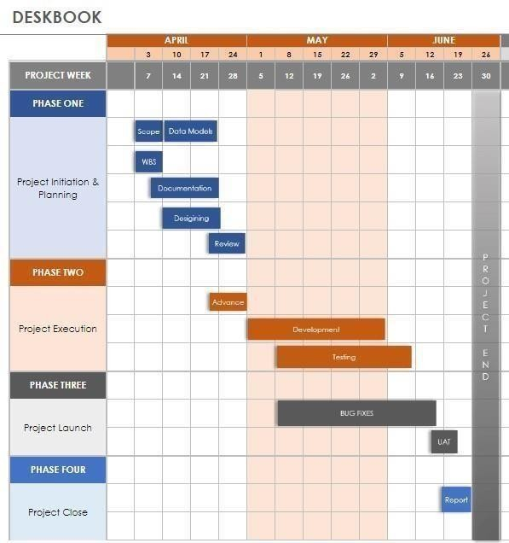

[Figure 4.4.] TIMELINE CHART

# CHAPTER 5. SYSTEM DESIGN

## USE CASE DIAGRAM

Define: A use case diagram is a type of diagram in software engineering that depicts the interactions between a system or software application and its users or other systems. It is used to illustrate the functionality and behaviours of a system from a user's perspective.

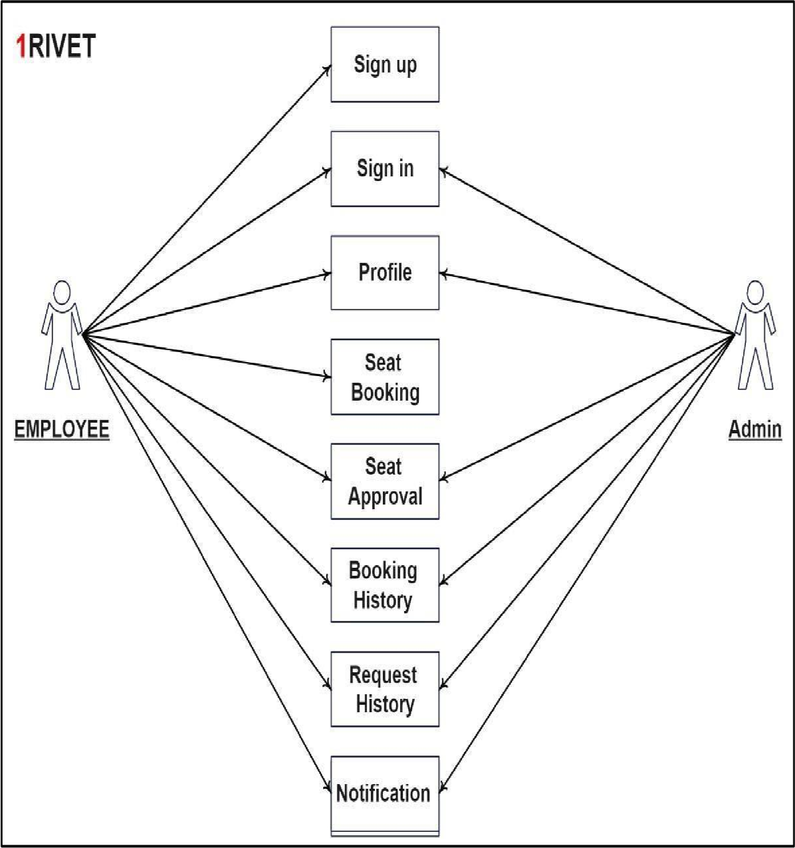

[Figure 5.1.1] USE CASE DIAGRAM

A use case diagram for a desk booking application would illustrate the various use cases and interactions between the users of the application and the system itself.

## SEQUENCE DIAGRAM

Define: A sequence diagram is a type of interaction diagram in UML (Unified Modelling Language) that illustrates the flow of messages and interactions between objects or components in a system or software application. It shows the order in which messages are exchanged between different components and how they are processed to achieve a specific goal.

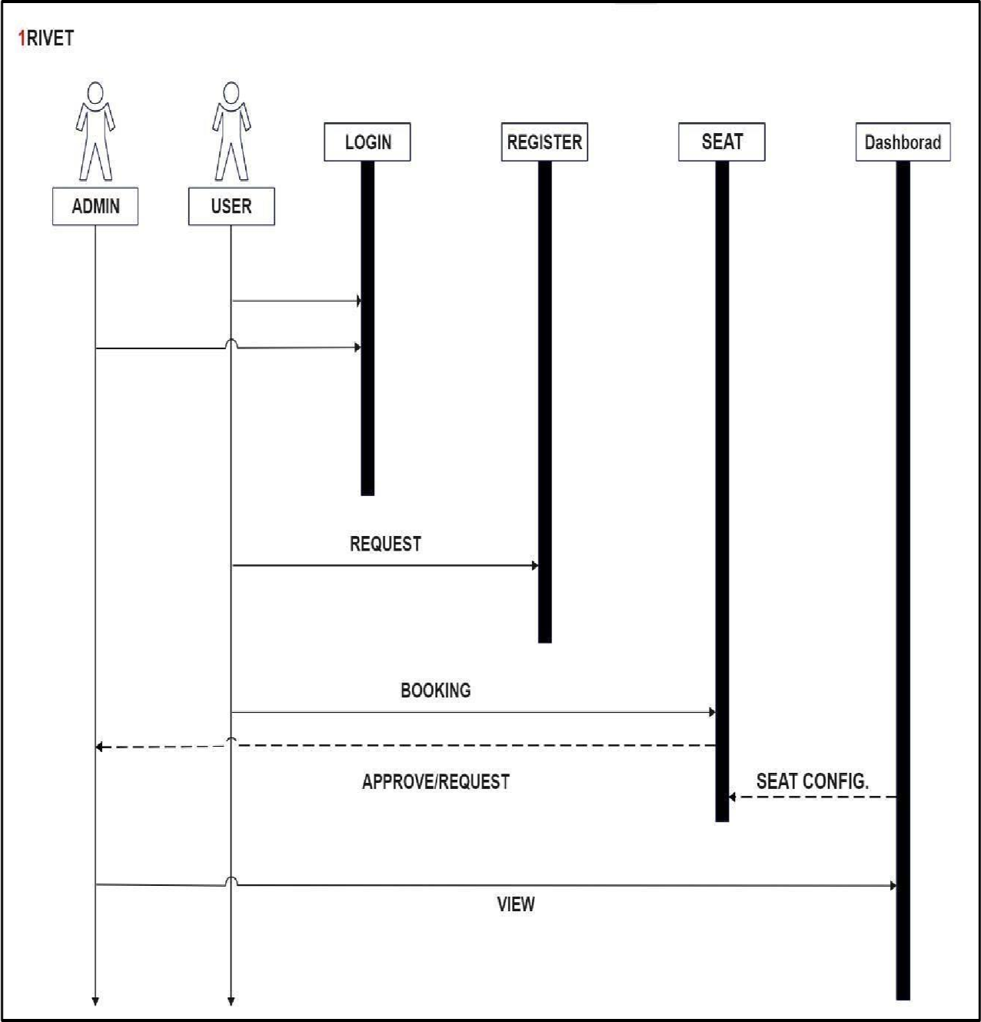

[Figure 5.2.1] SEQUENCE DIAGRAM

A sequence diagram for a desk booking application would illustrate the order of messages and interactions between various components of the system when a user is booking a desk.

Gujarat Technological University **21** GEC, Dahod

## ACTIVITY DIAGRAM

Define: An activity diagram is a type of UML (Unified Modelling Language) diagram that is used to model workflows or processes in a system or software application.

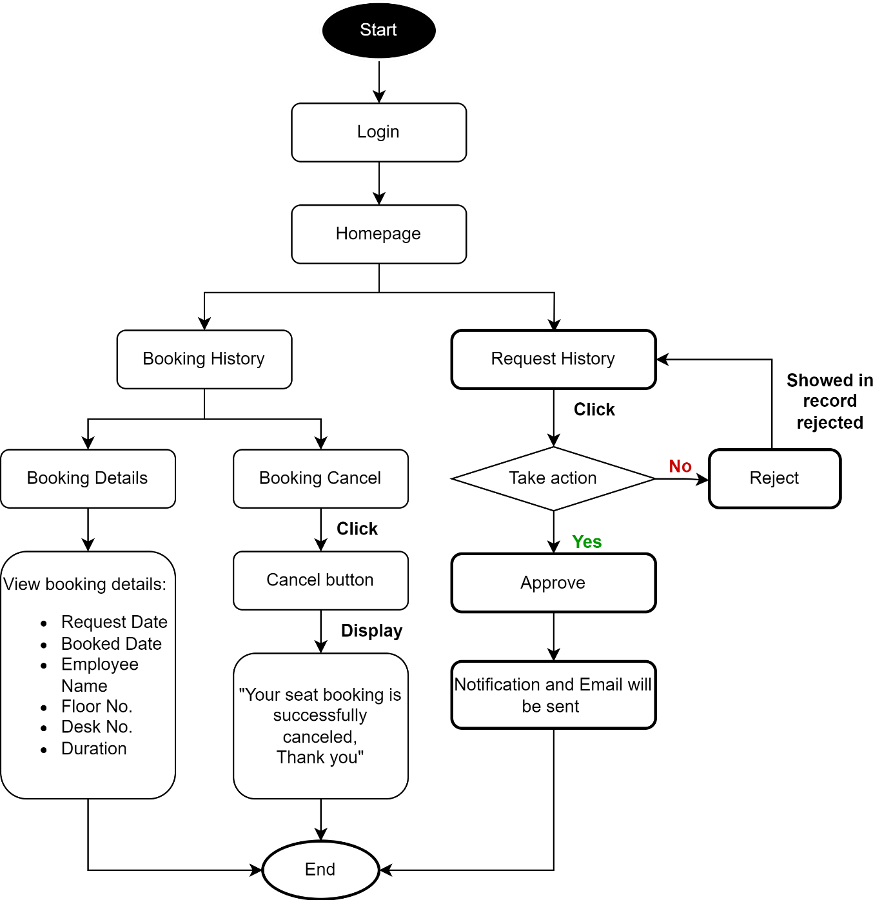

**[**Figure 5.3.1 ]ACTIVITY DIAGRAM

Gujarat Technological University **22** GEC, Dahod

An activity diagram for a desk booking application would illustrate the various activities and workflows involved in the process of booking a desk.

## DATA MODEL

Define: A data model is a conceptual representation of data objects, relationships between them, and the rules that govern those relationships.

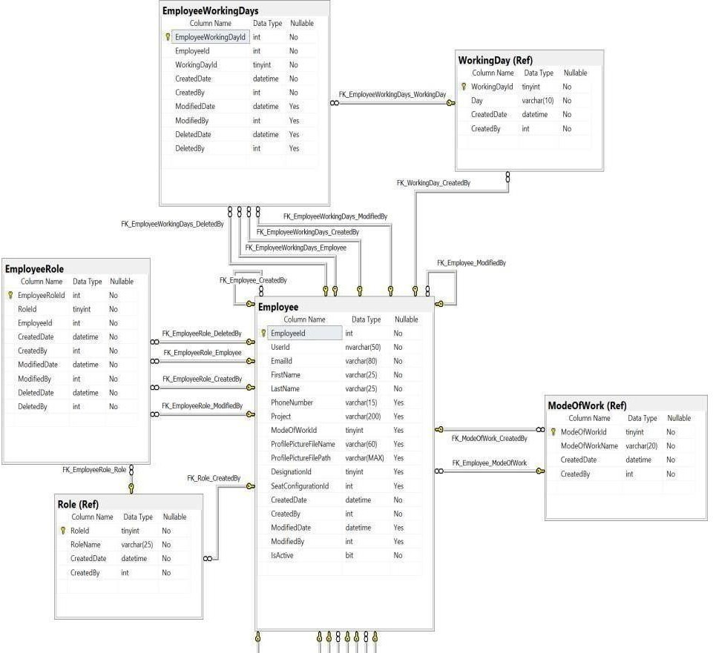

Gujarat Technological University **23** GEC, Dahod

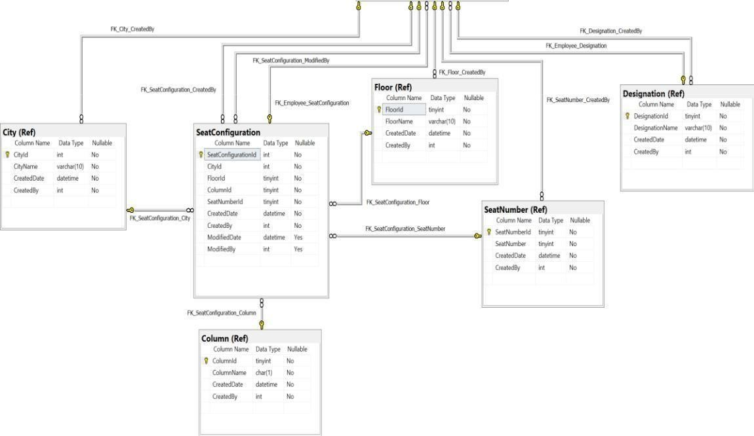

[Figure 5.4.1] DATA MODEL

Gujarat Technological University **24** GEC, Dahod

# CHAPTER 6. IMPLEMENTATION AND TESTING

## HARDWARE AND SOFTWARE REQUIREMENTS

## Hardware Requirements :

* Processor: Intel Core i3 or higher
* RAM: 4 GB or more
* Hard Disk Space: 500 MB or more
* Display: Minimum 1366 x 768 resolution • Network: Wired or wireless network connection

## Software Requirements:

* Operating System: Windows 8 or macOS Sierra or later versions
* Web Browser: Google Chrome, Mozilla Firefox, Safari or Microsoft Edge
* Database: MySQL or SQL Server
* Server: Apache Tomcat or Microsoft IIS
* Programming Languages: Angular, Java, Python, or .NET, DevOps

Gujarat Technological University **25** GEC, Dahod

## SNAPSHOTS

## Register Form

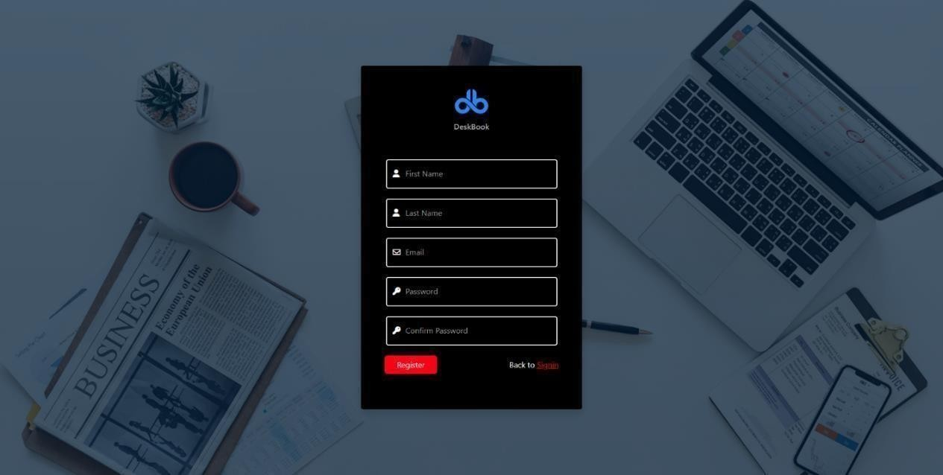

[Figure 6.2.1] Register Form

Allows user to register in the application and once the user is registered the system shall process and redirect to the Sign In page. All the fields have validation. If user fills any wrong information or any invalid type then it will show error and message will be displayed about filling the right information in that particular field. When all the fields will be valid then only user will be able to submit the form and register himself/herself. When onced registered he/she will be redirected to the sign in page.

## Figure 6.2.2 Sign-in Page

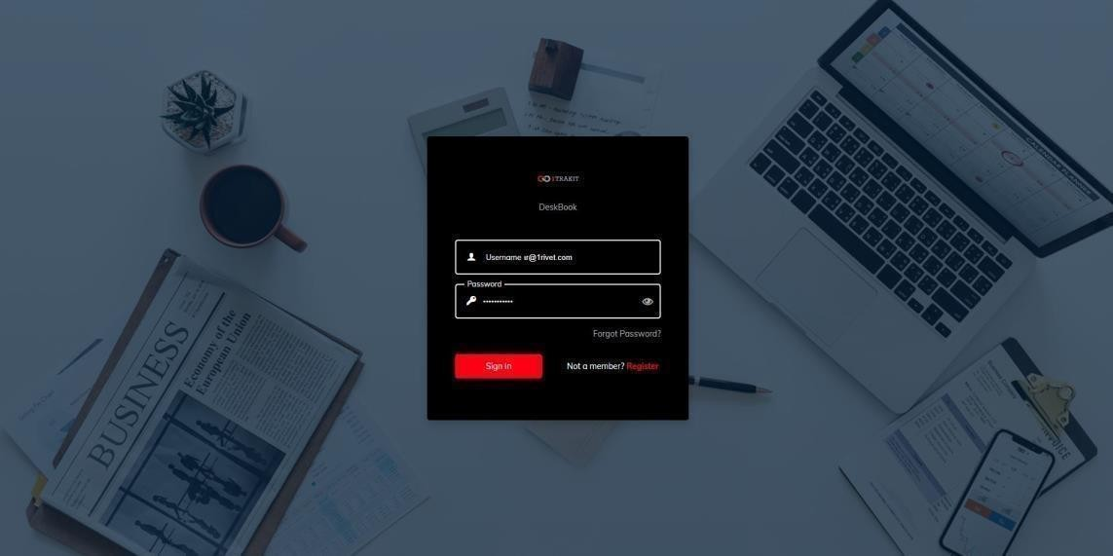

[Figure 6.2.2] Sign-in Page

Allows the user to login in the Deskbook Application so that the user can have access to the application. When registered email will be saved in the server, so now at the time of sign in it will check if the user is registered or not and will validate by checking the server for the mail entered in the sign in with the server mail when registered. Once all fields are valid then only user will be redirected to the dashboard.

## Forgot Password

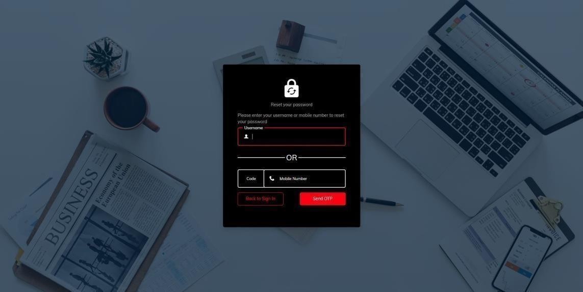

[Figure 6.2.3] Forgot Password

If user forgets the password then he/she can click on forgot password and redirected to reset password. User can provide registered mail in the field and receive otp. When entered here user will be redirected to the reset page so user can create new password and use it in future for sign in .

## Reset Password

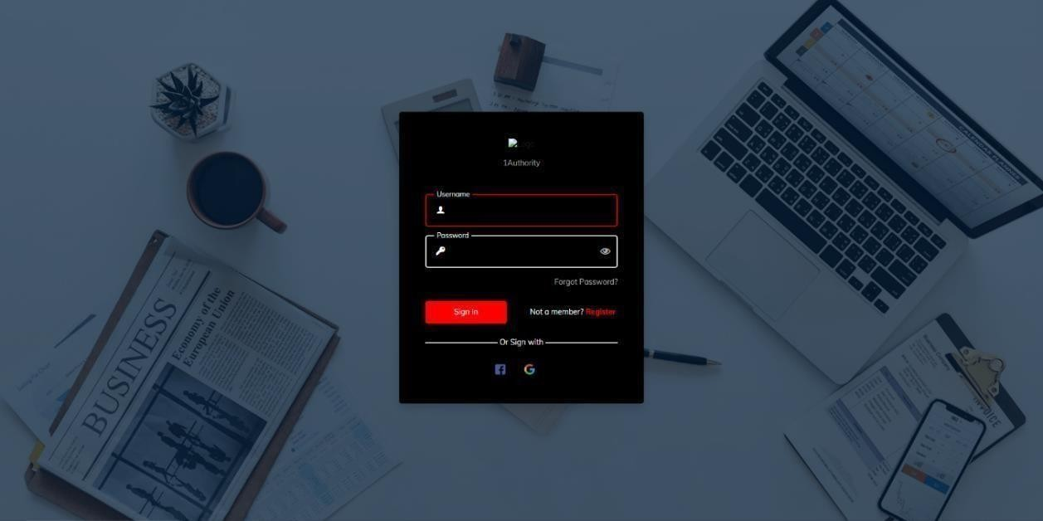

[Figure 6.2.4] Reset Password

Allows the user to reset the password. When user forgets password he/she can reset password and use it for sign in purpose and use the application. When once user resets password he/she will be redirected to the log in page and user can use it to pass the guard set by developer.

## Loading Page

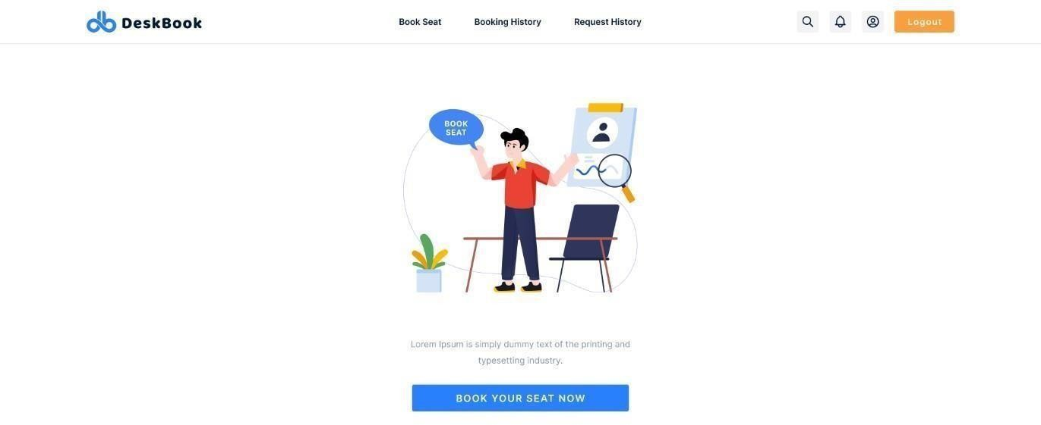

[Figure 6.2.5] Loading Page

Allows the user to book the seat, see booking history and request history in addition provides the option to logout. When user successfully log in he/she will be redirected to the dashboard where user will be able to book seats and send request to other’s for seat and admin will have his/her authority for request and other purpose.

## Search Employee

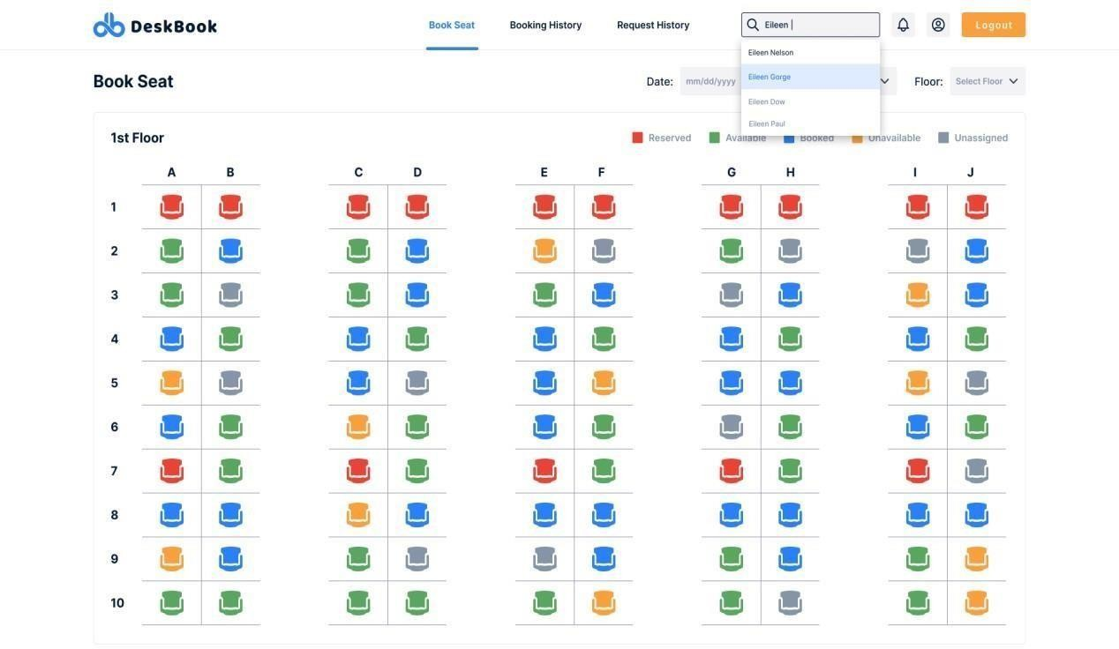

[Figure 6.2.6] Search Employee

Using Search filter, we can find information about employee and where he/she is sitting and also we can check whether his/her seat is available for the request or has been taken by any employee. If admin wants to know about any particular employee he/she can find using this search filter and get information about it.

## Profile of Searched Employee

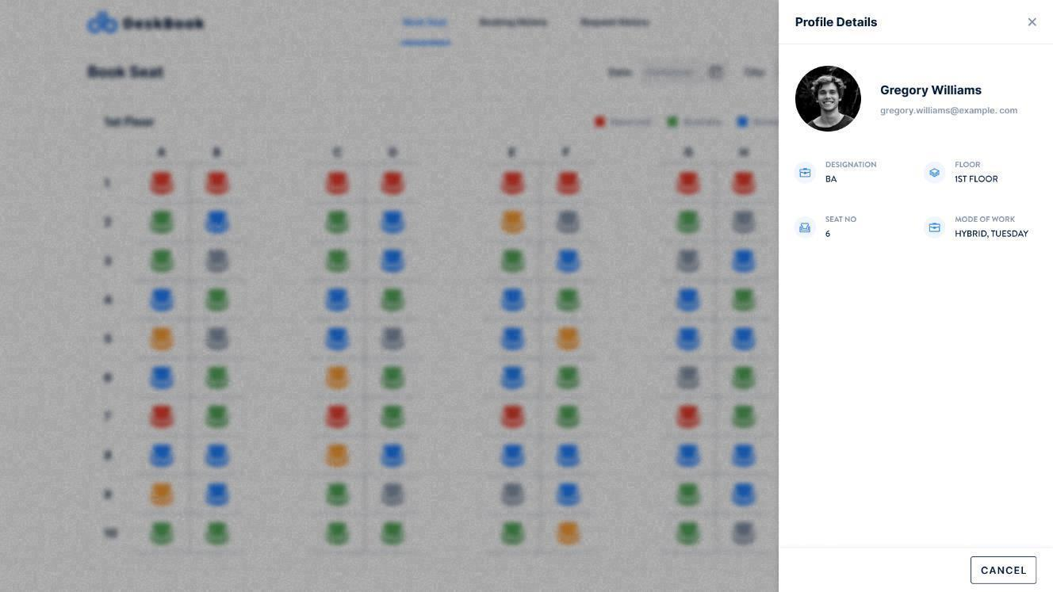

[Figure 6.2.7] Profile of Searched Employee

When user’s name is searched in the search bar it filters the data of all the employee and shows the employee we are searching for if that employee exits in the database.

Admins can get information about any employee like where they are seating or like on which floor they seat and other basic information about that employee. They can also know that the employee is doing hybrid work or work from office.

## Request History

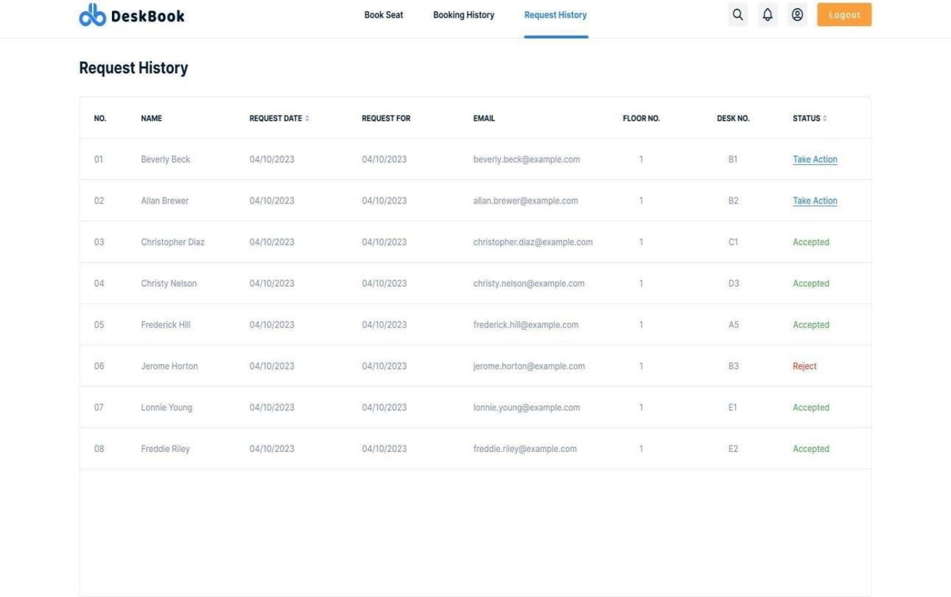

[Figure 6.2.8] Request History

Once the employee sent request to the other employee regarding using the seat for day then the request it directly sent to the employee where he/she can act according to their will and response towards it. They may reject also, and they may accept request also but if employee is unable to act on the request then first employee to send request to that employee will automatically get approved and will be reserved for him/her, but that’s the case when employee is unable to act, and it’s first come first serve base.

## Request Action

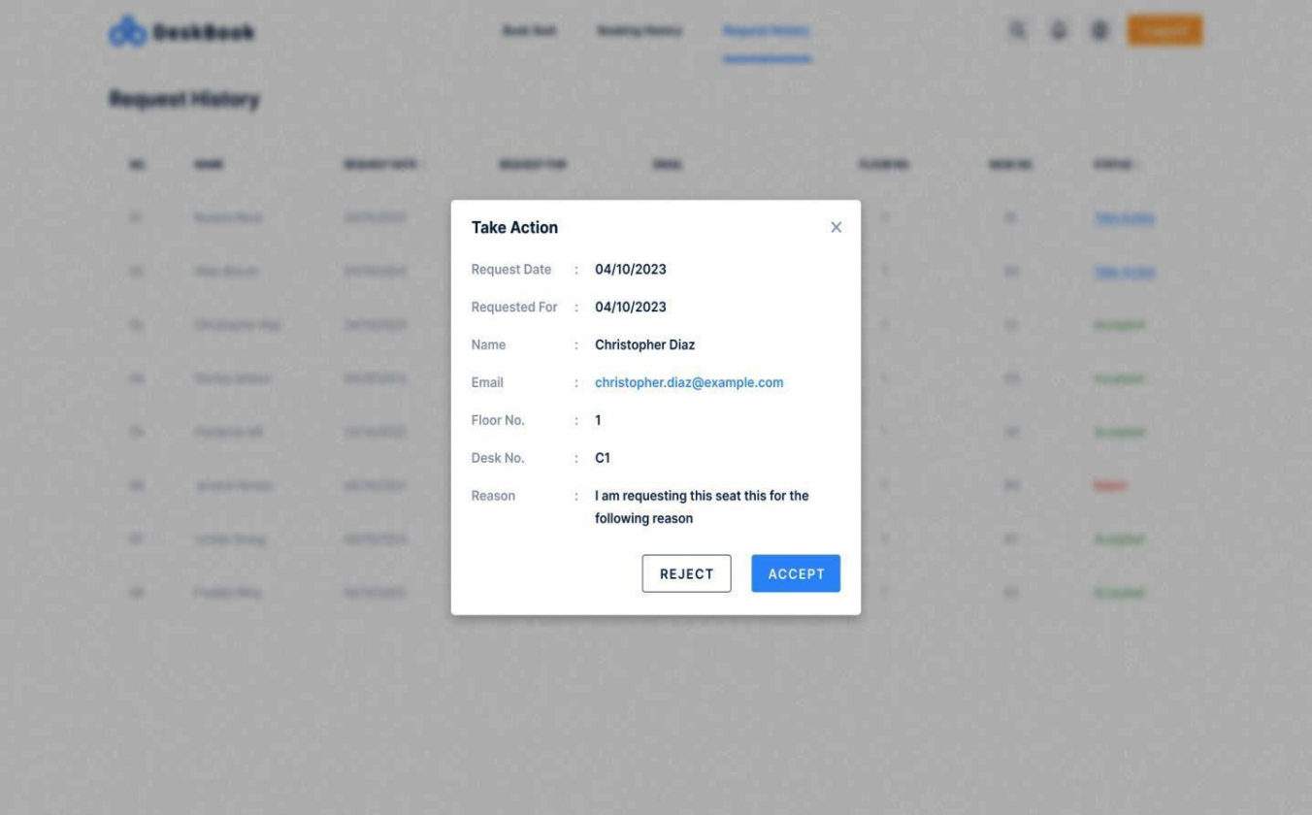

[Figure 6.2.9] Request Action

When the employee send’s request to the employee whose seat he/she want to acquire for particular day, it shows to the employee, and he/she can take action whether to accept the request or want to reject it. When employee takes any action requester employee gets the notification of getting his/her seat booked. It will give all the data like on which day, which seat will be used by that employee.

## Notification Page

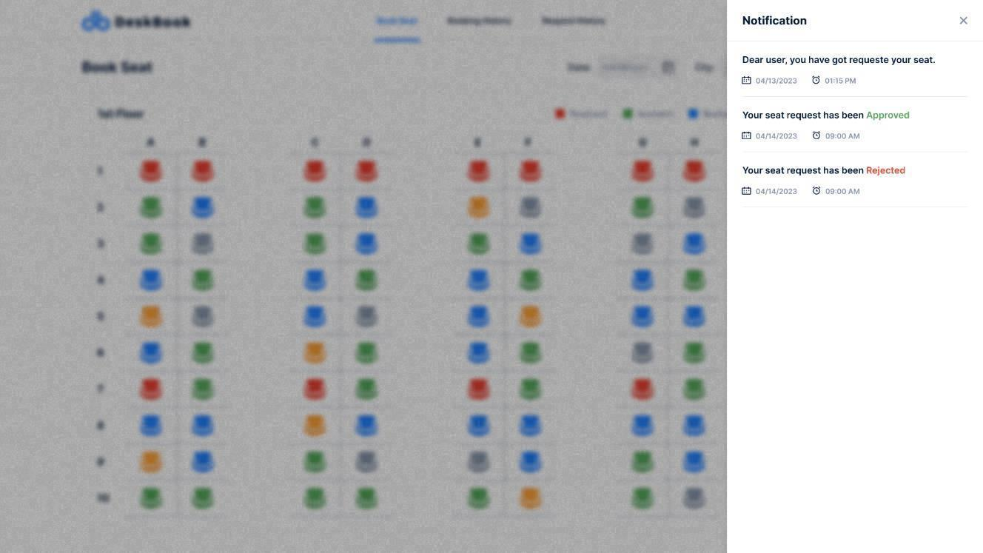

[Figure 6.2.10] Notification Page

When employee whose seat is requested once accepts, a notification to the requesting employee will be sent stating the action taken by the employee. Request may be accepted, or mat be rejected the notification will state that to the requester. This way if user can’t get that seat he/she may try for other seat as the procedure should be taken before 3 to 4 days so employee can get seat they wanted.

## Requested Dashboard

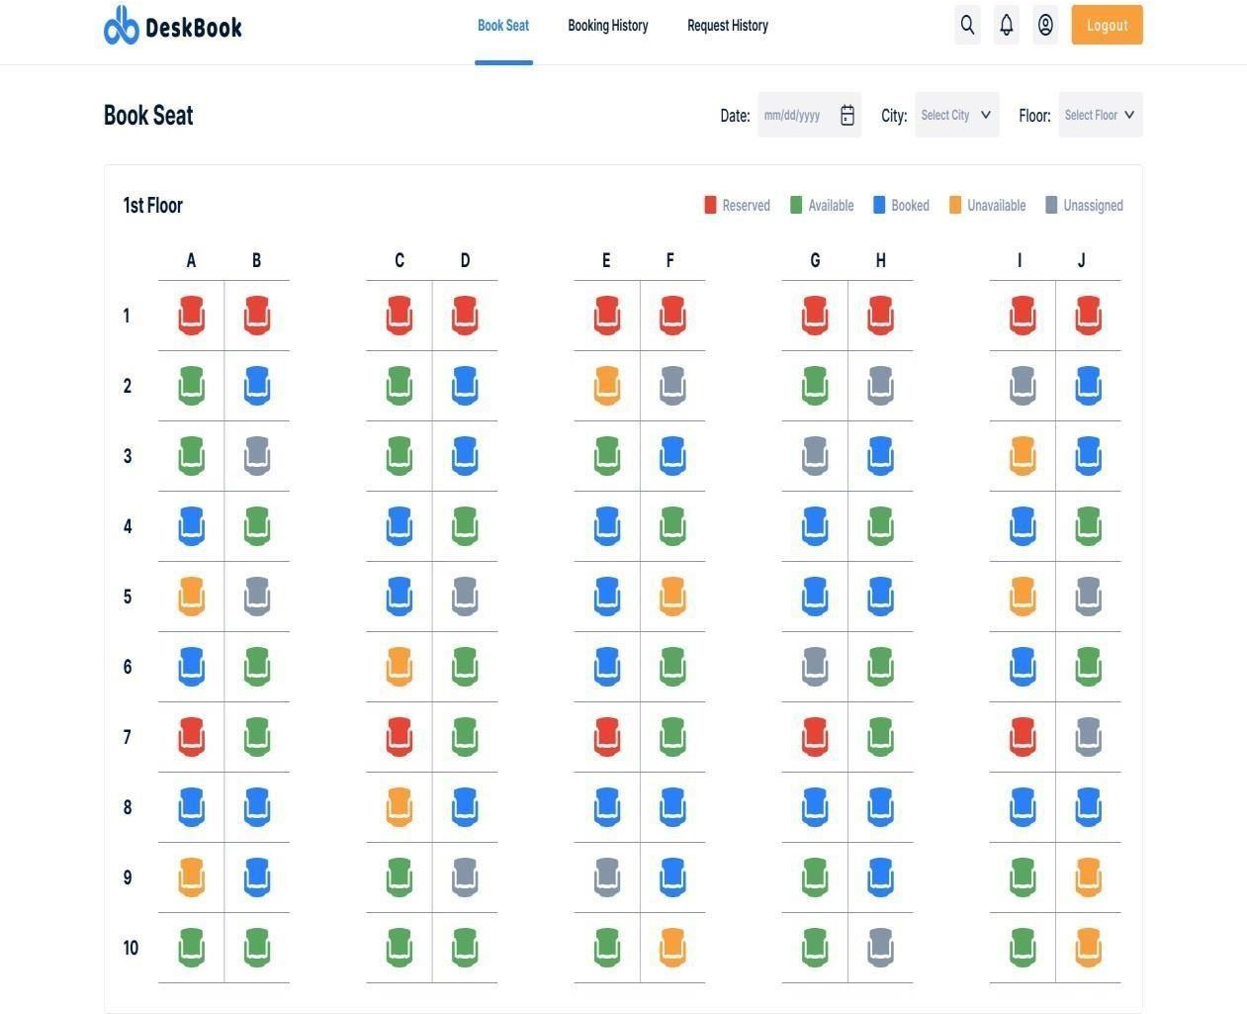

[Figure 6.2.11] Requested Dashboard

When user logs in he/she will be redirected to the landing page and will be able to book seat according to the user’s preference. Different colours of the seats have different meaning. Red is specially for only admins and Infra team or any other higher authority. Green is for Available seats for employees to send request. Blue is for the seat’s which are reserved by other employees. Grey is for the seats which are newly allocated and only admins can accept the request for that seat. Yellow is for the seats which are temporary unavailable for any employee to use due to any issue at the system or maintenance issues. Users can send request to the green seats only.

## Reserved Seat

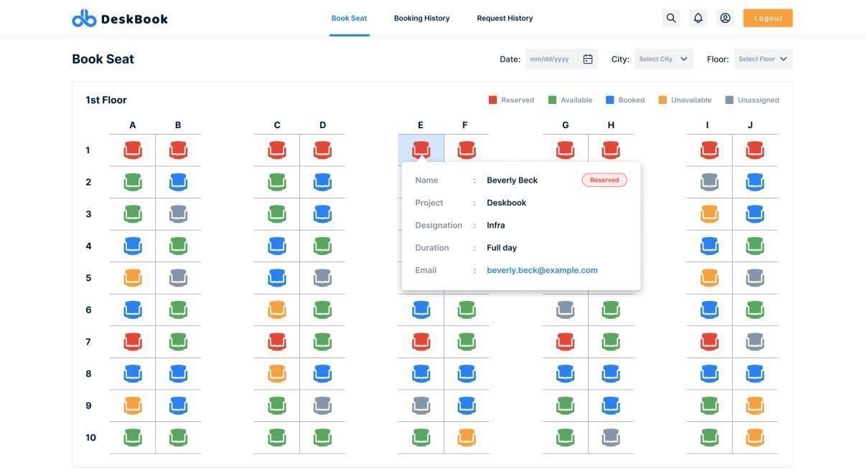

[Figure 6.2.12] Reserved Seat

Employee can request for any seat they want accept thee red once as they are already reserved for admins only. Higher authority can access this seat according to their will and manage it but for normal employees it is not available. Employees can view whether this seat is filled by which admin but can’t sent request for that seat.

## Figure 6.2.13 Temporary Unavailable

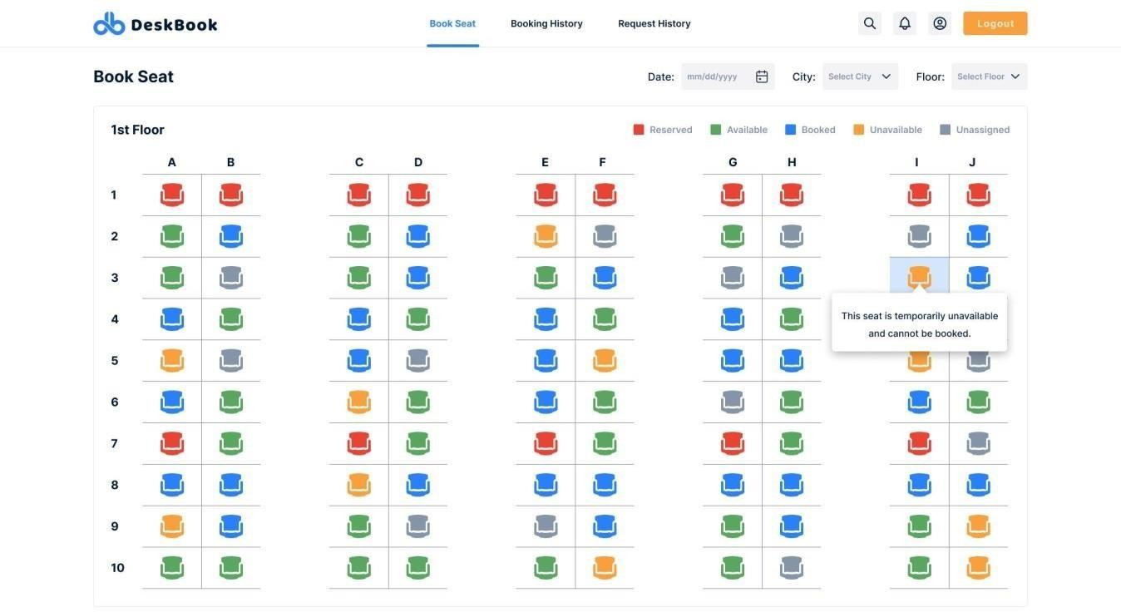

[Figure 6.2.13] Temporary Unavailable

Yellow seats are the seats where employee can’t send request for some period of time as it shows that it is under maintenance, or the system is facing issues so it is marked in yellow. Once the system is fully functioning it will again be able to the employee for request.

## Request Pop-Up

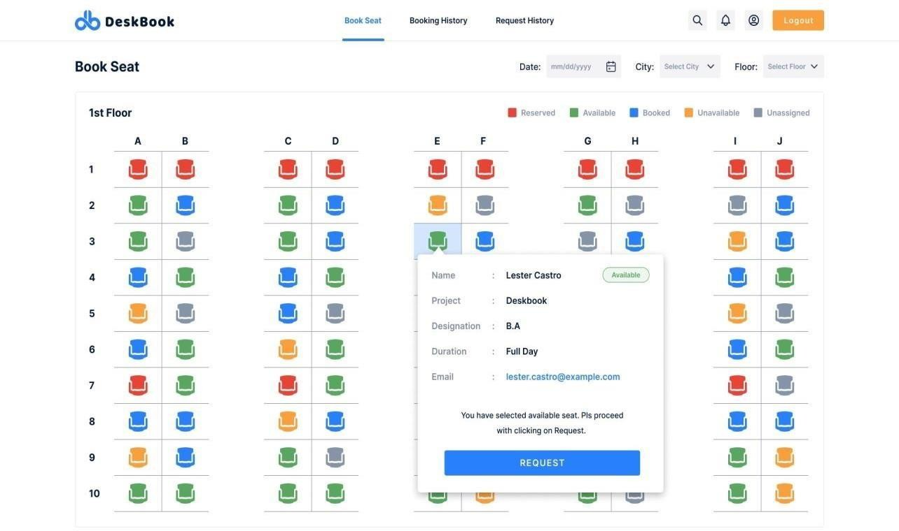

[Figure 6.2.14] Request Pop-Up

When employee wants to come to office for work he/she can request to other employee who will be unavailable that day. We can request that employee if and only if they are in green coloured seat. This shows that it is available to other users for that day. By clicking on that green seat user can send request to another employee whose seat he want book.

## Reason Pop-Up

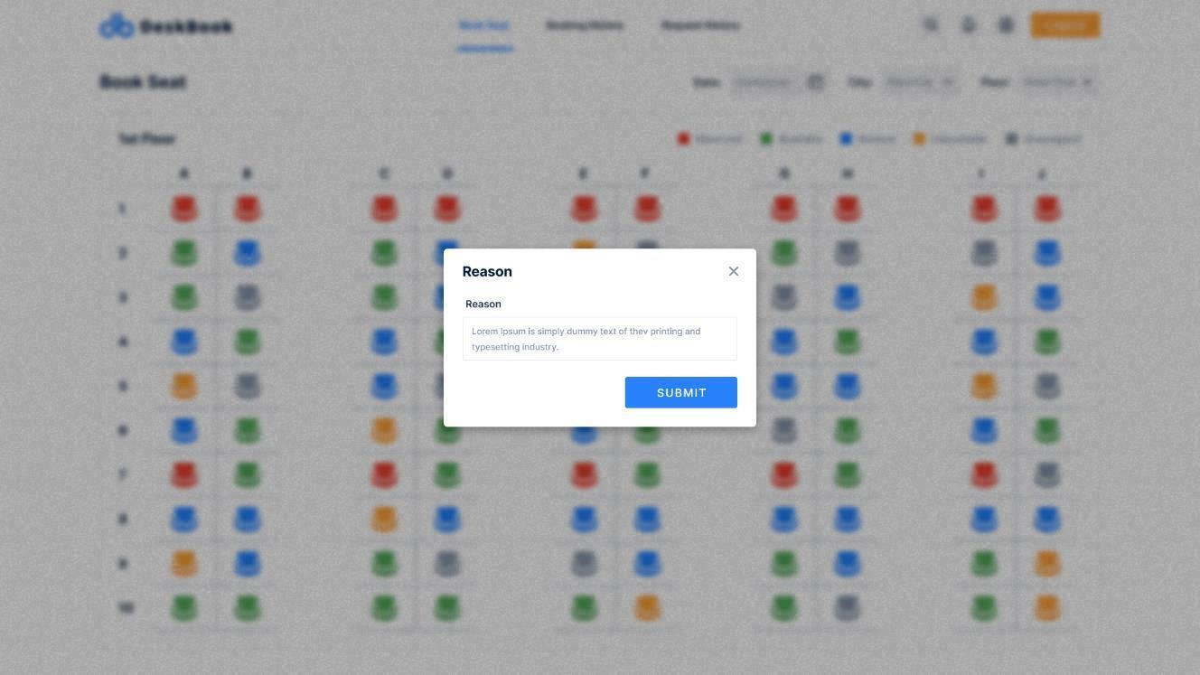

[Figure 6.2.15] Reason Pop-Up

When employee request to the other employee for the seat requester needs to give a valid reason why do employee need that seat and purpose of the seat. Once the requester employee provides valid reason then he/she can submit the request and notification will be sent to employee whose seat is. He/she then take action whether to accept or reject the request

## Successful Request Pop-Up

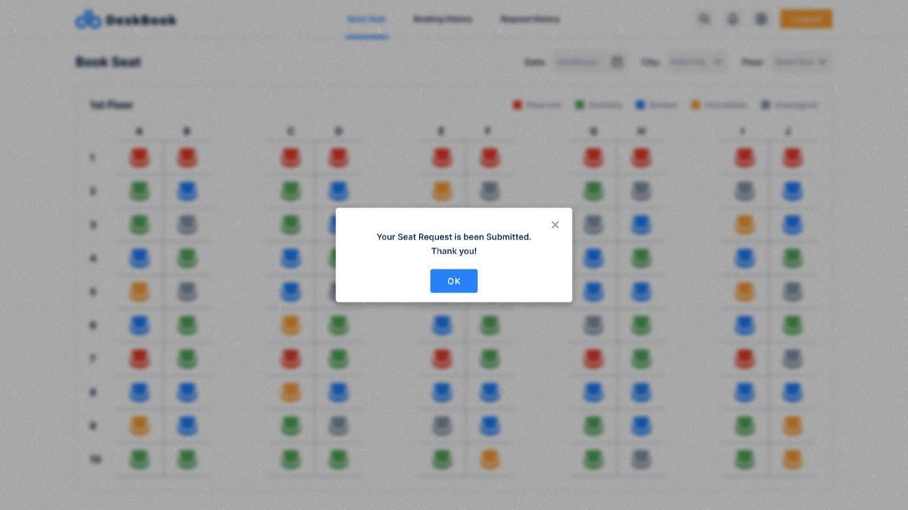

[Figure 6.2.16] Successful Request Pop-Up

Once the user sends the request to the employee he/she will get a pop-up of request sent successful. Then employee will get notification whose seat it is and can act regarding that.

## Booked Seat Information

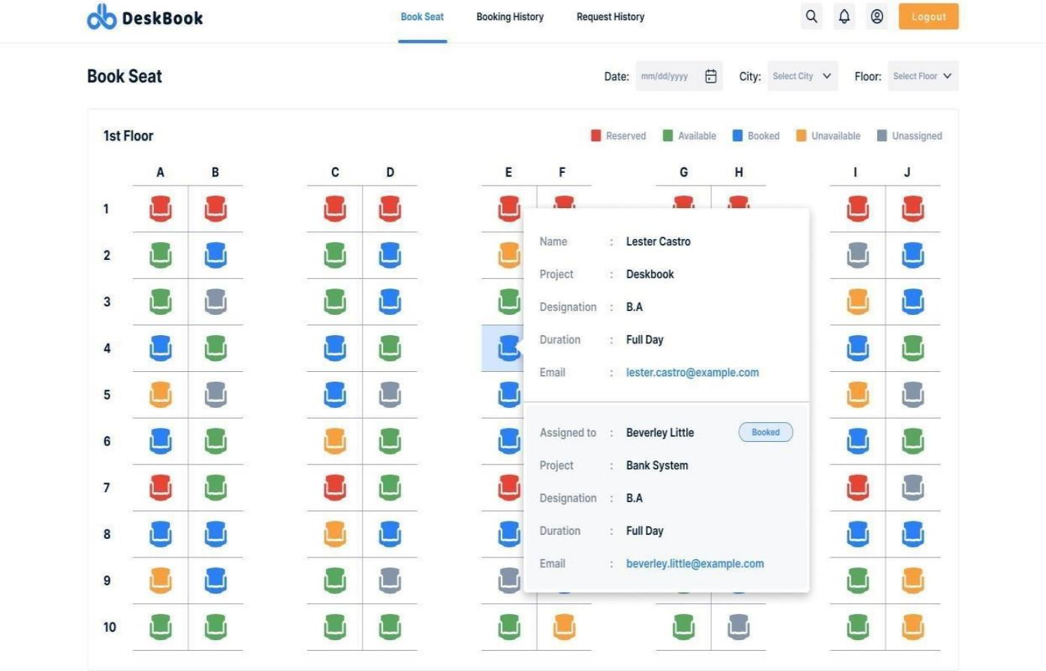

[Figure 6.2.17] Booked Seat Information

When the request of requester employee gets confirmed he/she will receive a notification regarding the action taken by the employee. If the seat is confirmed then when the employee clicks on that seat they can view by whom the seat is been reserved and get a basic information about the employee who booked the seat and whose seat it is.

## Request Direct Admin

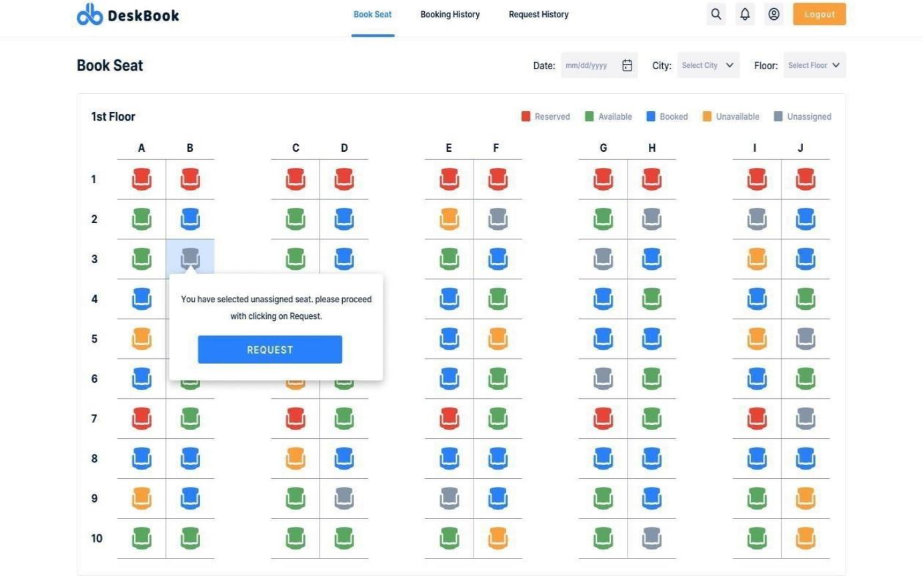

[Figure 6.2.18] Request Direct Admin

There are some seats which are not assigned to any employee and are recently added to the floor. When the requester employee wants to get that seat then he/she can request by clicking on the seat, but the request will be sent directly to the admin. So the action will be taken by admin so the seats which are newly added till any employee is assigned to that seat. This seat are in grey colour so it is known to the employees that it is newly added to the floor.

## Employee Profile

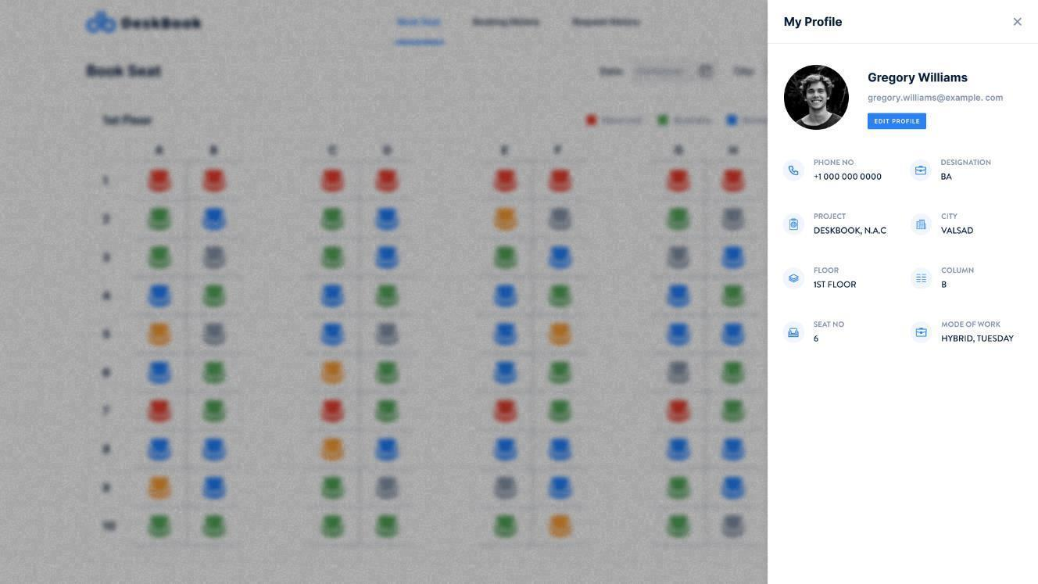

[Figure 6.2.19] Employee Profile

When any other employee or admin want to know where a particular employee seats or needs any basic information about employee. When searched about employee his profile will be displayed with basic information like his/her full name, his/her floor number, city, seat number and some other information too.

## Detail Profile

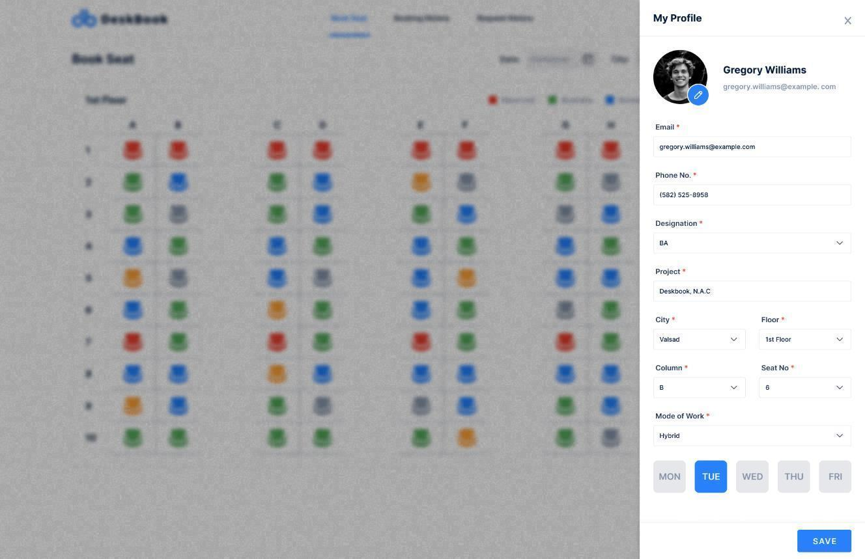

[Figure 6.2.20] Detail Profile

When employee firstly registers himself/herself then he/she have to fill these basic details about himself/herself. It will help others to know about the employee have booked the seat or is requesting for the seat. It has options of hybrid work, work from office and work from home also. If hybrid worker is filling the detail it gives option when will he/she will be coming to office and for how many days. This data can be edited by the employee whenever he/she wants.

## Booked History

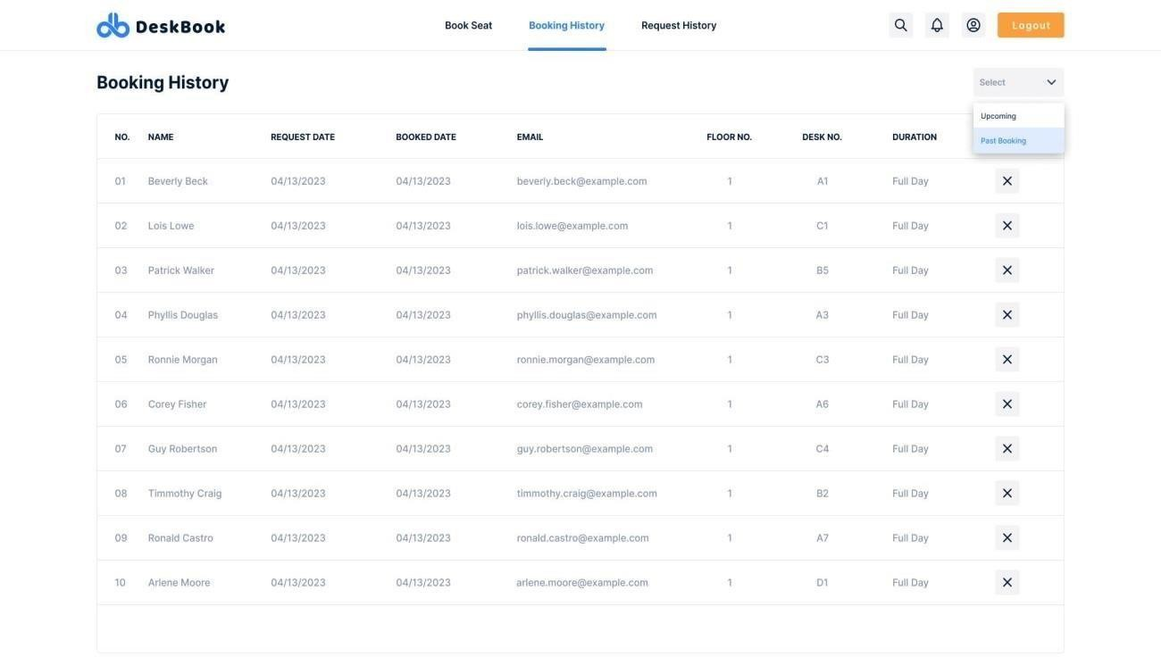

[Figure 6.2.21] Booked History

All the request which are received by the employee from the requester employee will be saved to know which employees requested earlier and get to know the actions taken by himself/herself. It has filter option of upcoming requests or history of the requests.

## Cancel Confirmation

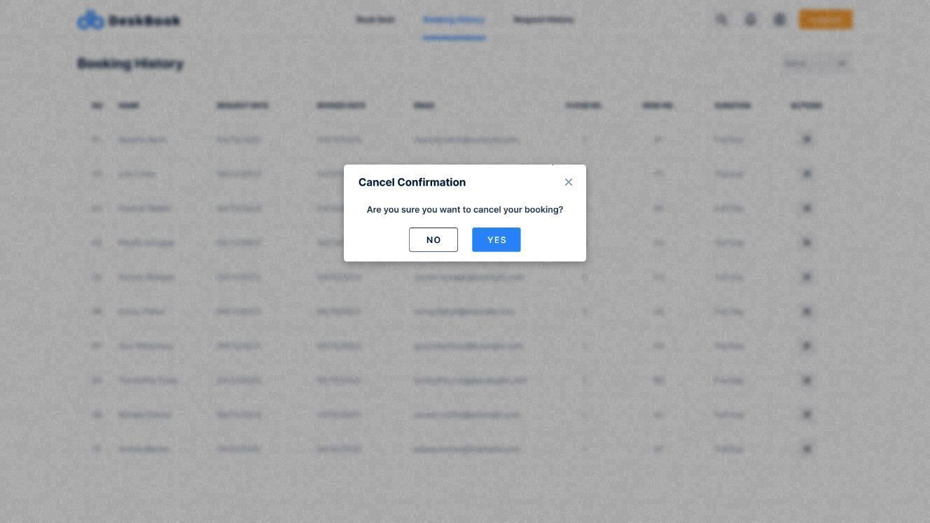

[Figure 6.2.22] Cancel Confirmation

If requesting employee got some emergency and in not going to the company for the particular day on which booked can also cancel the booking and make it available to other employees who are going to come on that particular day and book seat. This way no seats are wasted and helps other employees to book the seat.

## Floor Selection

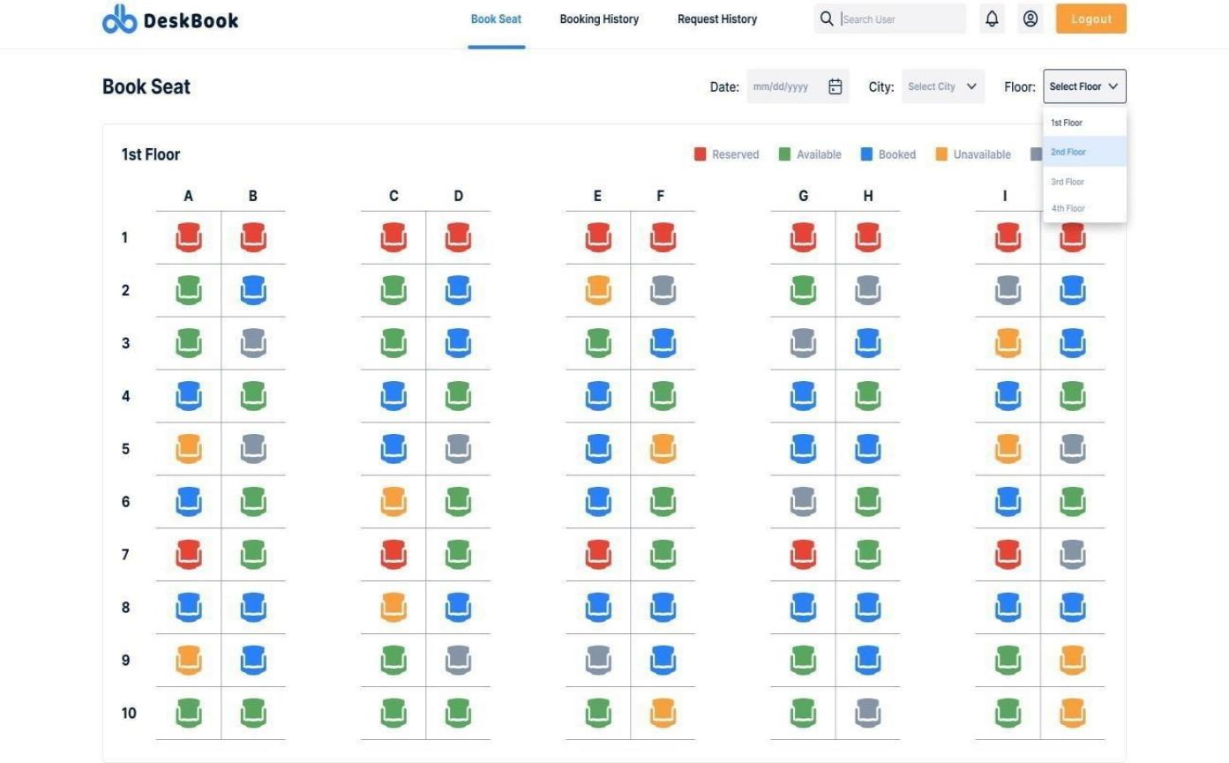

[Figure 6.2.23] Floor Selection

When user wants to book seat he can choose on which floor he/she want to book seat on. This makes employee more comfortable to work with. This will filter aout the floor and will provide all the seat details to the employee that on that particular floor which seats are available and which are booked.

## Date Selection

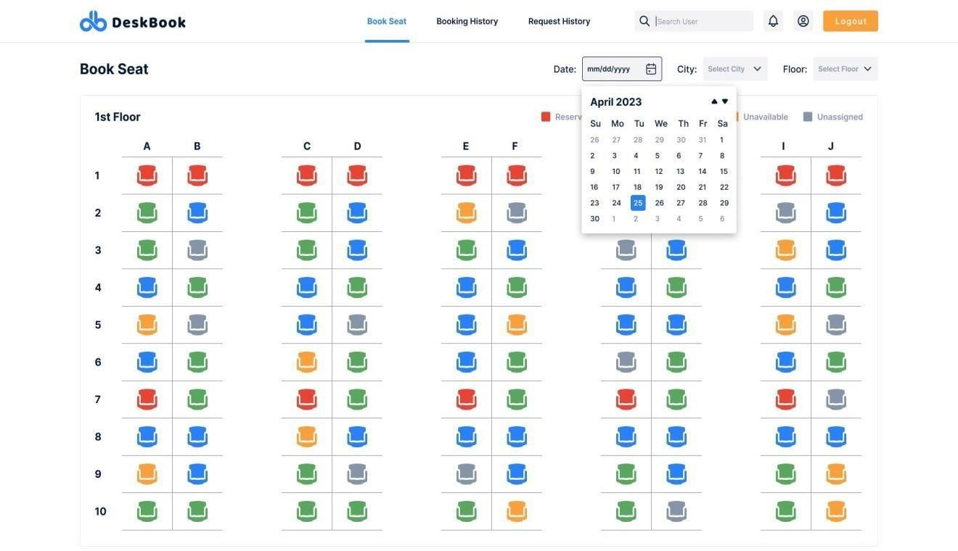

[Figure 6.2.24] Date Selection

When employee wants to request he/she will first select the date from the calendar that on which day he/she want to book the seat. Selecting the date will filter out the seats according to the floor he/she want to book seat on. This way employee will be comfortable to use the seat he/she wanted to use.

## TEST CASES

[Table 6.3. 1] TEST CASES

|  |  |  |  |  |  |
| --- | --- | --- | --- | --- | --- |
| **Test ID** | **Case** | **Test Data** | **Expected Result** | **Actual Result** | **Pass/**  **Fail** |
| 1 | Sign In | Email Id , Password | User will be redirected to the Home Page | User will be redirected to the Home Page  . | Pass |
| 2 | Forget Password | Email  ID, New Password,  Confirm Password | If Email ID is valid and authorized  then new password is set by received mail | If Email ID is valid and authorized  then new password is set by received  mail | Pass |
| 3 | Sign up | User  Name, Email ID, Password | User will register with proper Details | User will register with proper Details | Pass |
| 4 | Home Page | Select Notification, Search  Employee, Profile | User will see the profile detail, Search Employee Seat, see the  notification | User will see the profile detail, Search Employee  Seat, see the notification | Pass |

|  |  |  |  |  |  |
| --- | --- | --- | --- | --- | --- |
| 5 | Book Seat | Select Seat Booking,  Notification, Search  Employee, Profile | User will Book a Seat, see the profile detail, Search  Employee Seat, see the notification | User will Book a Seat, see the profile detail  ,Search  Employee  Seat, see the notification | Pass |
| 6 | Profile | Select Profile | User will View or Edit Profile Details | User will View or Edit Profile Details | Pass |
| 7 | Logout | Select Logout | User will be redirected to the Sign in Page | User will be redirected to the Sign in Page | Pass |

# CHAPTER 7. CONCLUSION AND FUTURE SCOPE

## OVERALL ANALYSIS OF INTERNSHIP:

* + - * In conclusion, a desk booking application is an essential tool for modern workplaces, especially in today's fast-paced and flexible work environments. It offers a streamlined way to manage workspace reservations, reduce conflicts, and optimize space utilization, resulting in increased productivity, improved communication, and cost savings.
      * By implementing a desk booking application, organizations can provide their employees with a flexible and user-friendly way to book workspaces, thus enhancing their overall work experience. Moreover, desk booking applications can help organizations adapt to the changing needs of their workforce, allowing them to scale up or down as needed while still optimizing their workspace utilization.
      * In Future work, Desk booking applications are becoming increasingly popular as more companies move towards flexible work arrangements and remote work. The future scope of desk booking applications is bright, and it is expected that the demand for such applications will only increase in the coming years. Integration with other workplace management software, Advanced features, Improved user experience.
      * The future of desk booking applications looks bright as more companies recognize the benefits of flexible workspace arrangements and invest in tools to optimize their workplace management.

## SUMMARY OF INTERNSHIP:

* + - * This report is a reflection of the learning and experience acquired through an opportunity.
      * During my internship a 1RIVET INDIA, I was introduced to some new technologies, frameworks, and languages.
      * I get to know how real-time organizations work. What is their professional approach to deal with clients and Team.

# REFERENCE

**Web References**

1. MDN Web Docs:<https://developer.mozilla.org/en-US/docs/Web>
2. W3Schools:<https://www.w3schools.com/>
3. CSS-Tricks:<https://css-tricks.com/>
4. jQuery:<https://jquery.com/>
5. Angular: <https://angular.io/>
6. SQL:<https://www.sql.com/>
7. Redux:<https://redux.js.org/>
8. Agile Methodology:<https://www.agilealliance.org/agile101/>
9. Smashing Magazine:<https://www.smashingmagazine.com/>
10. Code Pen :<https://codepen.io/>

Gujarat Technological University **54** GEC, Dahod